



Machine Learning

What is Azure Machine Learning?

Contents

The Problem Domain

First Time Setup

The Data

Data Pre-Processing

Training the Model

Optimising Classifiers

Creating a Scoring Experiment

Publish as a Web Service

Testing the Web Service

Publish to the Gallery

Conclusion

Introduction

First Time Setup

The Data

Data Processing

Training the Model

Comparing Classifiers

Publish as a Web Service

Visualise Results

Conclusion

Extra Resources

This lab will introduce you to machine learning capabilities available in Microsoft Azure. Microsoft Azure Machine Learning (Azure ML) allows you to create basic designs and complete experimentation and evaluation tasks.

What is Azure Machine Learning?

In this lab, we will cover Azure ML Studio, a fully managed machine learning platform that allows you to perform predictive analytics. Azure ML Studio is a user facing service that empowers both data scientists and domain specialists to build end-to-end solutions and significantly reduce the complexity of building predictive models. It provides an interactive and easy to use web-based interface with drag-and-drop authoring and a catalogue of modules that provide functionality for an end-to-end workflow.

In some scenarios a data scientist may not understand the domain data as thoroughly as a domain expert does. Microsoft Azure Machine Learning has made it possible for the people who know the most about the data to produce predictive analytics for that data.

During this lab, you will create and publish a model that predicts if a flight will be delayed depending on a range of flight details and weather data. The two datasets used are flight delay data and weather data. These sets consist of records for flights and the weather at each airport on an hourly basis.

The Problem Domain

The columns of the flight delay dataset hold information such as the date and time of a flight, the carrier, origin and destination ID’s as well as delay time information.

The columns of the weather dataset hold information such as the Airport ID, date and time and various weather measures such as visibility and temperatures.

The model you will create is a form of supervised learning; we will use historical flight and weather data to predict if a future flight is delayed. This model will use a binary classification technique, is the flight delayed or not, and produce a web service you can query with new flights

The Microsoft Azure ML Studio is in the Azure Management Portal, therefore you will need an Azure subscription to complete the lab.

First Time Setup

You can sign up for a free Azure one month trial; using your Microsoft account; where you get £125 to try out all the services in Azure.

Sign up to Azure for one month free trial here: <http://azure.microsoft.com/en-gb/pricing/free-trial/>

If you don’t have a Microsoft account, create one here: <https://signup.live.com/signup.aspx>

Once you have an Azure subscription you can go to http://[www.azure.microsoft.com](http://www.azure.microsoft.com) and choose ‘My Account’ at the top of the page then choose the ‘Management Portal’ where it will ask you to sign in with your Microsoft account.

Once into the management portal scroll down the toolbar on the left side of the screen and find the Machine Learning Icon. To create a new workspace click on the ‘New’, ‘Data Services’, ‘Machine Learning’ and ‘Quick Create’.

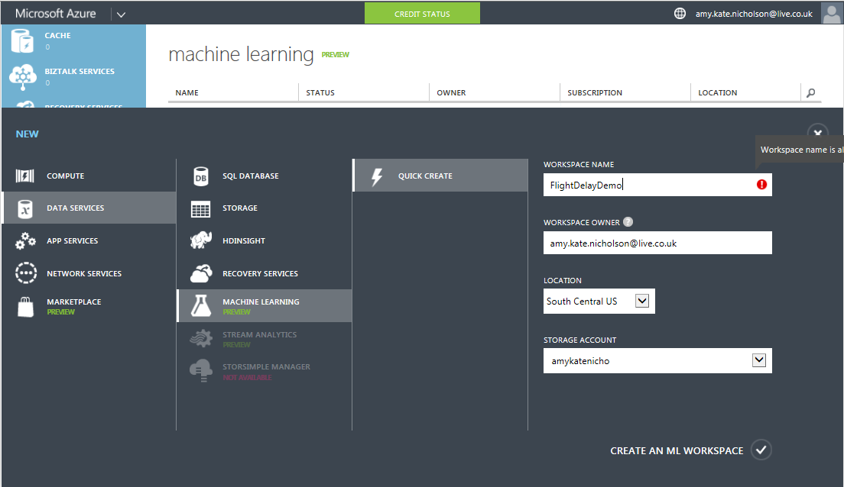

Enter details for all the variables below:

* **Workspace Name:** Pick a name for your workspace
* **Workspace Owner:** the Microsoft account to use to login to Azure ML.
* **Location:** South Central US (Expected to roll out to other regions soon)
* **Storage:** Create new storage account or pick the name of a current storage account.

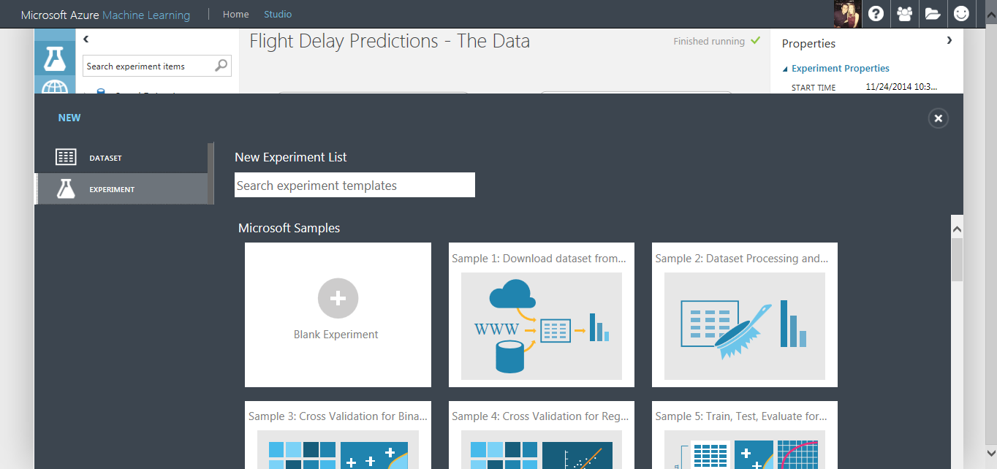Once on the Workspace homepage click on the link ‘Sign-in to ML Studio’ and you should land on an experiments page. From there find the ‘New’ button in the bottom left corner and choose ‘Experiment’ then ‘Blank Experiment’. Notice there are sample experiments you can also use, edit and build on top off.

From your new blank experiment your will land in your workspace. Make sure to give your experiment a good title like “Flight Delay Demo” so you can recognise it in the future

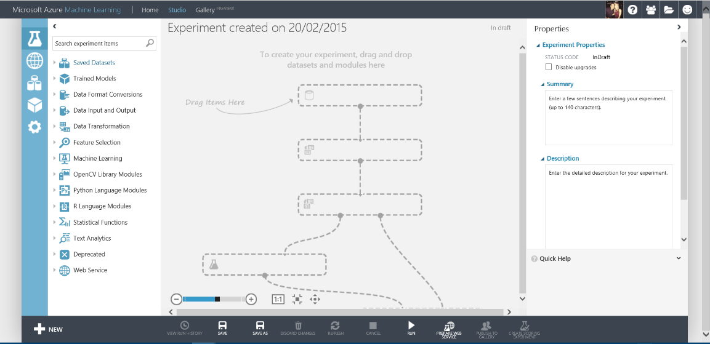

Now we can start building our experiment. In this section you will choose the flight delay and weather data and convert them into recognised datasets. Options for ingesting data into Azure ML Studio are:

The Data

* Using saved datasets listed in the left hand modules menu
* Upload data files from your local machine. Azure ML accepts many formats including CSV, TSV, Plain Text and Zip files
* Alternatively, you can use the Reader Module to access your data from sources such as SQL Azure, Blob storage and HD insight.

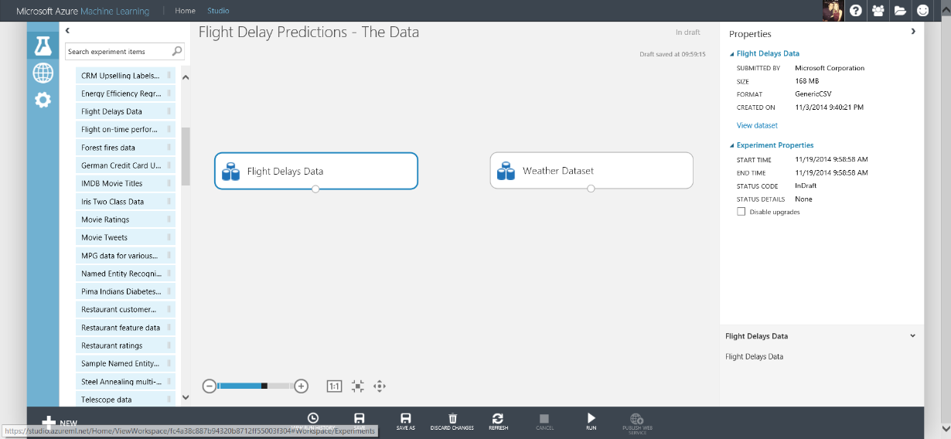In this experiment we will use the saved datasets ‘Flight Delays Data’ and ‘Weather Dataset’ from the Module menu on the left side of the studio. Click and drag these on to the experiment workspace

Right click on the small dot at the bottom of the Weather Dataset module and choose ‘Visualise’. This view shows you the first few rows of the dataset and also various statistics about each column in the dataset. Notice, some of the rows which should be Feature Type = Numeric are actually FeatureType = String, for example ‘DryBulbFarenheit’

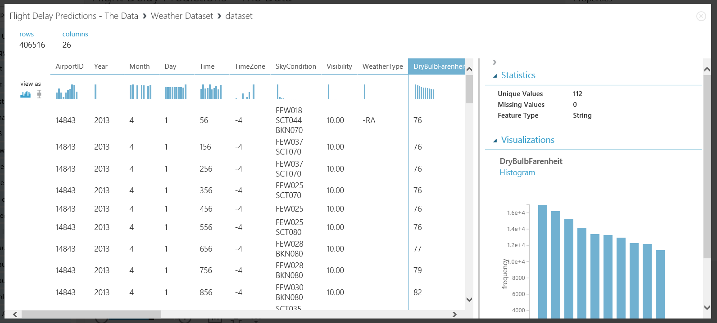

In order to solve this problem, drag and drop the ‘Convert to Dataset’ module and set missing values to ‘?’. Next connect the datasets and ‘Convert to Dataset’ modules together for both flight and weather data. Then Save and Run the experiment using the buttons in the bottom toolbar.

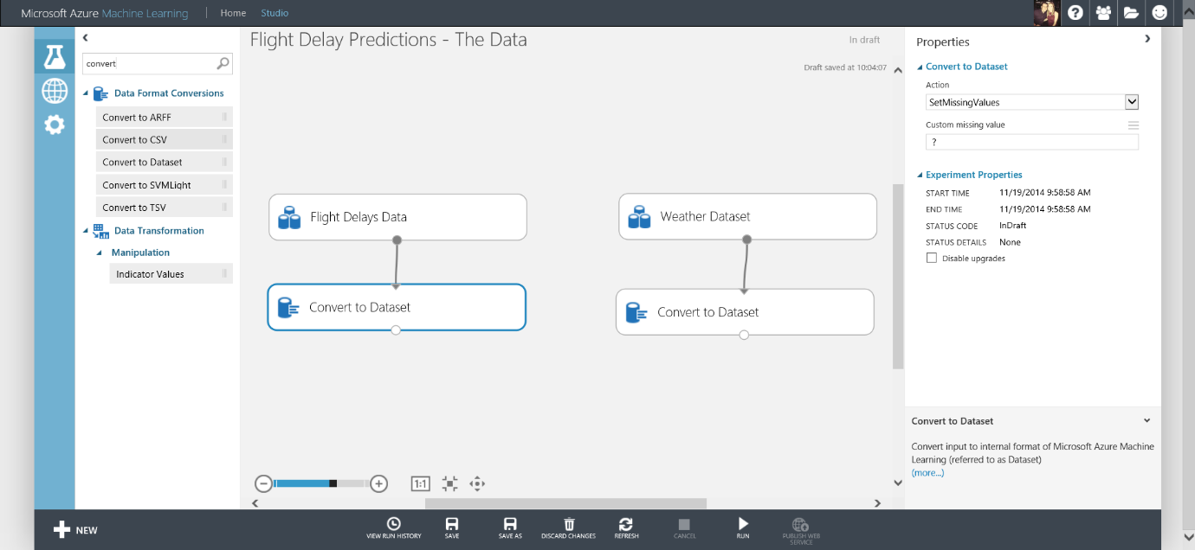**NOTE:** The ‘Custom Missing Value’ parameter for ‘Convert to Dataset’ module must be set to ‘?’ for flight delay and then ‘M’ (uppercase) for weather data. These are key symbols.

**NOTE:** you can type keywords into the search box on the left side of the workspace to find relevant modules to drag and drop into the experiment.

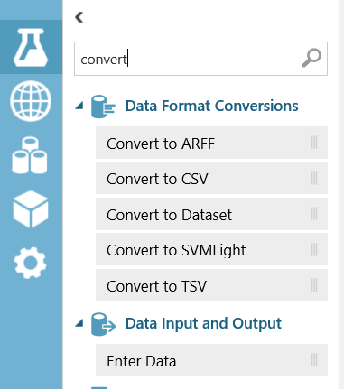

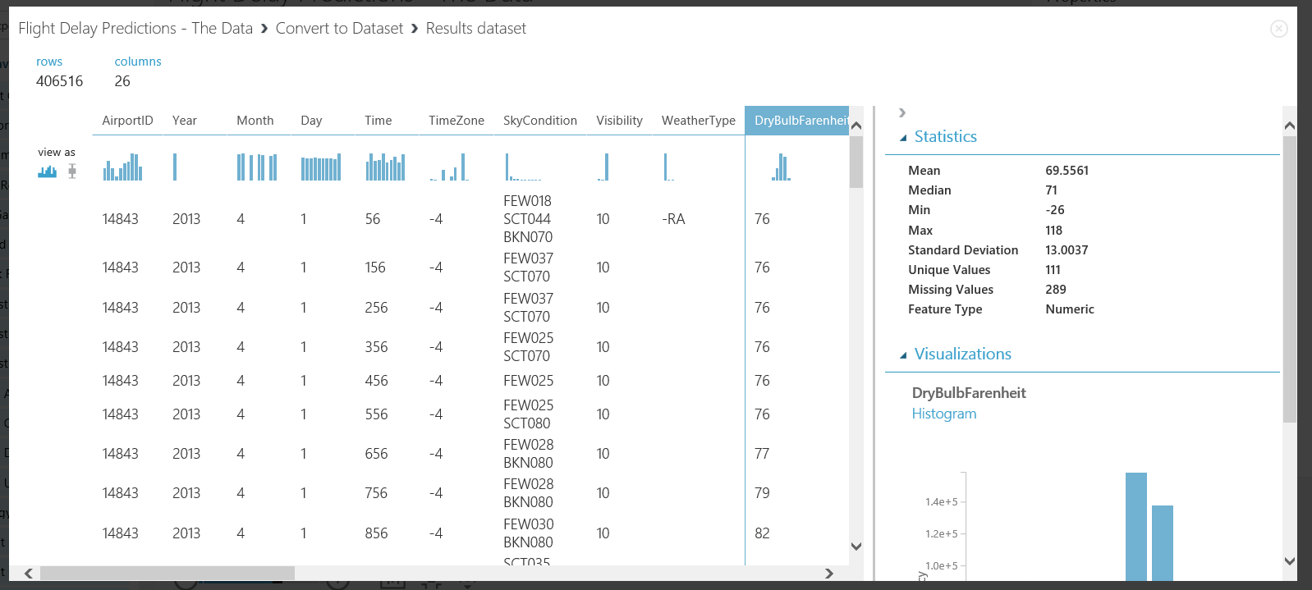When you see small green ticks by each module the experiment has run successfully. Now if you right click the bottom of the ‘Convert to Dataset’ module and choose ‘Visualise’ you will see the Feature Type is now correct for DryBulbFarenheit; numeric.

You have successfully completed selecting and converting the datasets, you are ready for further pre-processing.

The aim of this section is to get the data into a clean format and choose necessary data needed to train a model to predict if a flight is delayed or not.

Data Pre-Processing

There are many columns in both the Flight Delay and Weather datasets, some of these are not needed to predict if a flight is delayed or not, therefore to reduce computation time we will remove these columns

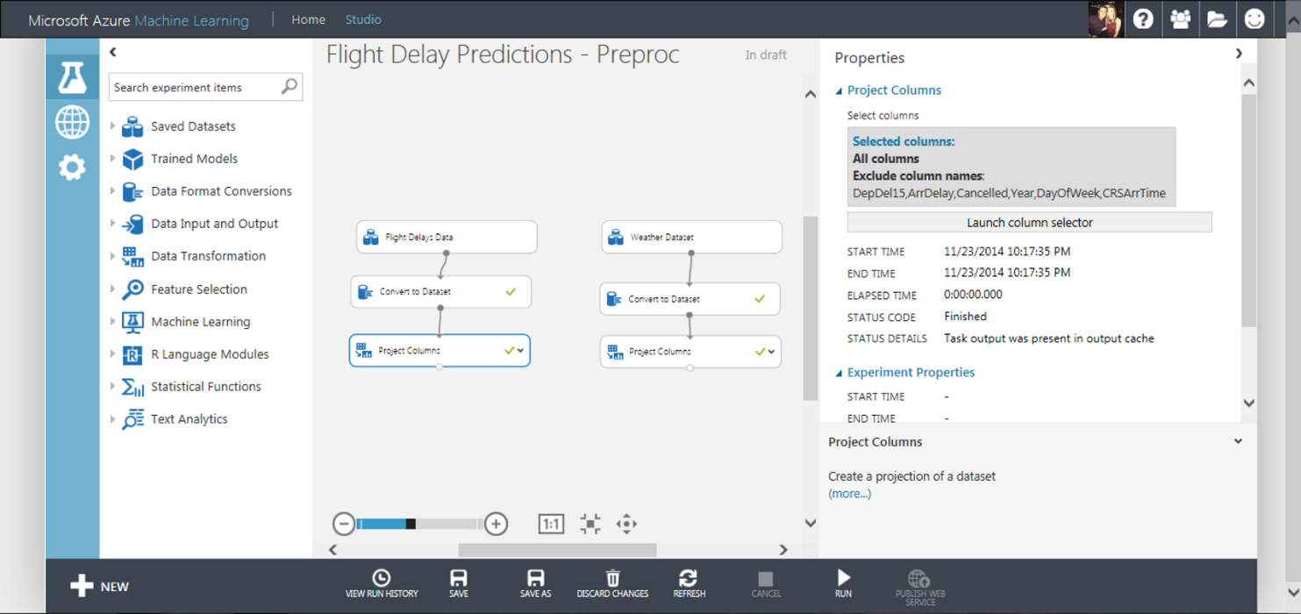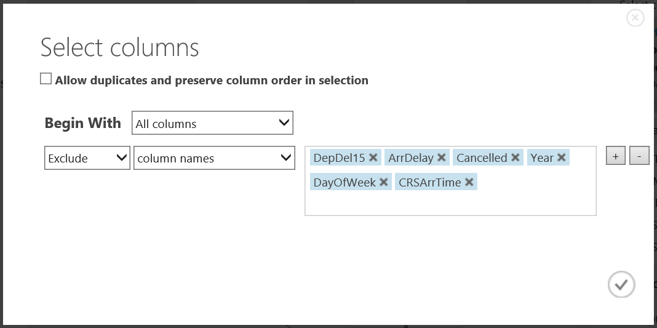Drag and drop a ‘Project Columns’ module onto the workspace and connect to the Flight Delay data branch of the experiment. In the Properties panel click launch column selector and choose ‘All Columns’, ‘Exclude’ ‘Column Names’ shown in the image below

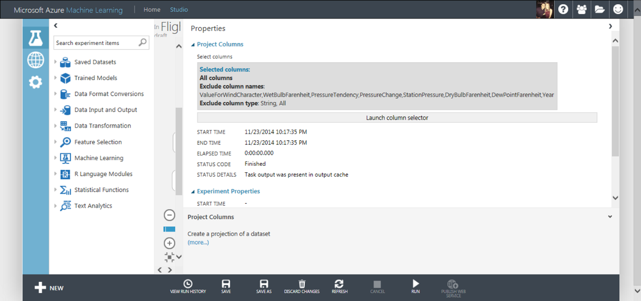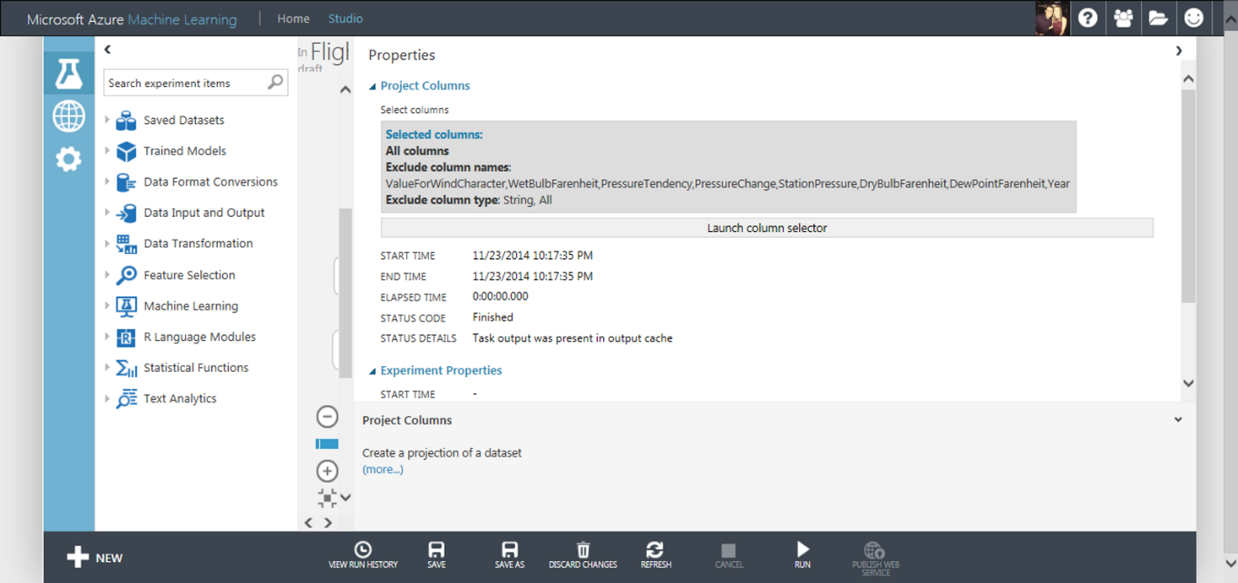Then do the same for the Weather Dataset branch of the experiment but exclude the column names shown below:

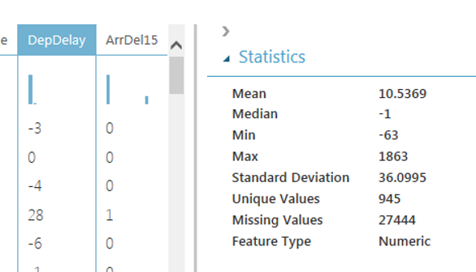Within both datasets there are some missing values in the data. We want full records of data in order to predict with confidence if a flight is delayed or not, therefore we will eliminate missing values using the Clean Missing Data module. For example DepDelay in the Flight Delay Dataset has 27444 missing values before applying this module.

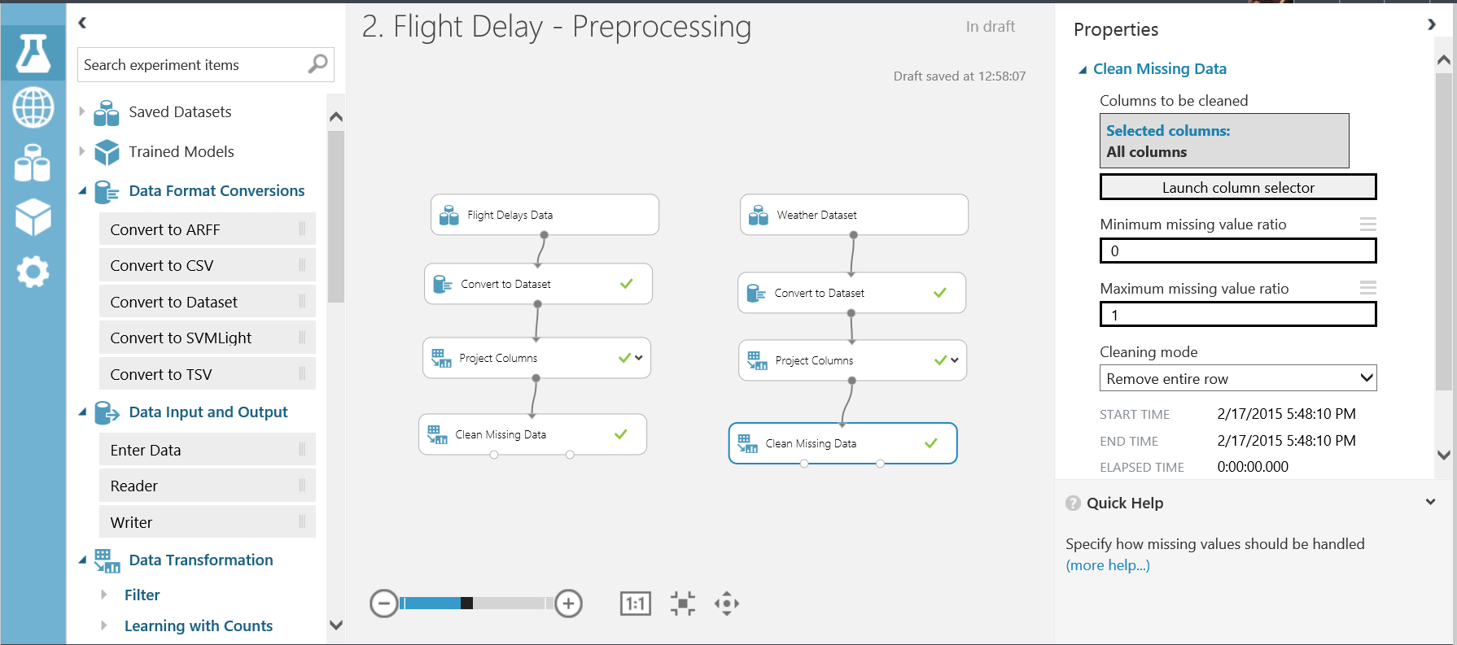Now drag a Clean Missing Data module onto the workspace and set the properties as shown below.

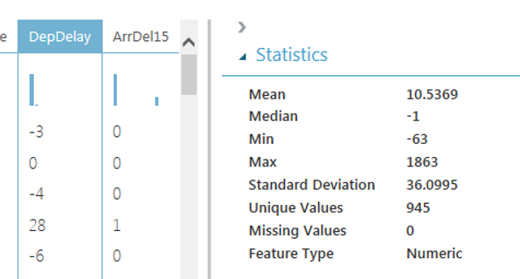Now Save and Run the experiment. If you right-click and ‘Visualise’ the data now from the left output port of the Clean Missing Values module and select the DepDelay column you will notice the amount of missing values is 0

Another useful module when pre-processing data is the ‘Metadata Editor’. This ensure Azure ML Studio handles the data correctly during ML problems. In this experiment some data value are code/ID’s for example AirportID, DestAirportID and OriginAirportID. These are categorical not continuous values and need to be treated as such. Add a ‘Metadata Editor’ module to the workspace and set choose the Carrier, OriginAirportID and DestAirportID columns and set the Categorical dropdown to ‘Make categorical’ 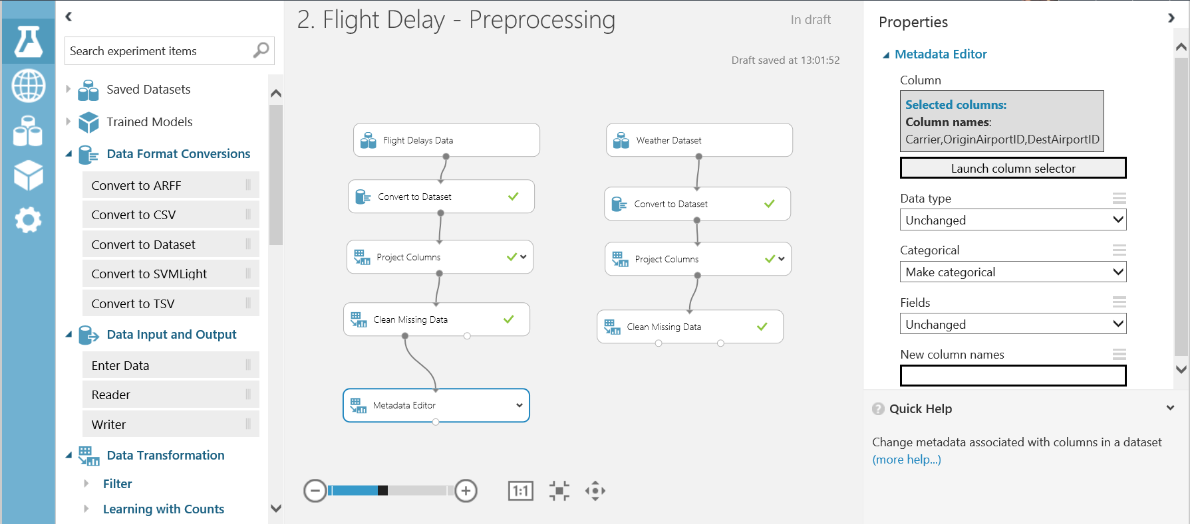as shown below

To predict if a flight is delayed we want use both the flight and weather data therefore we need to join the datasets. Currently we have month, day and AirportID that can join in each dataset, however we want to match on the time as well. Currently the flight time is to the nearest minute and the weather time recordings are once an hour at 56 minutes past.

Now we will transform the time and round to the hour. Drag and drop the ‘Apply Math Operation’ module onto the workspace and connect to the Flight Delay Data branch. Set the Properties as shown below:

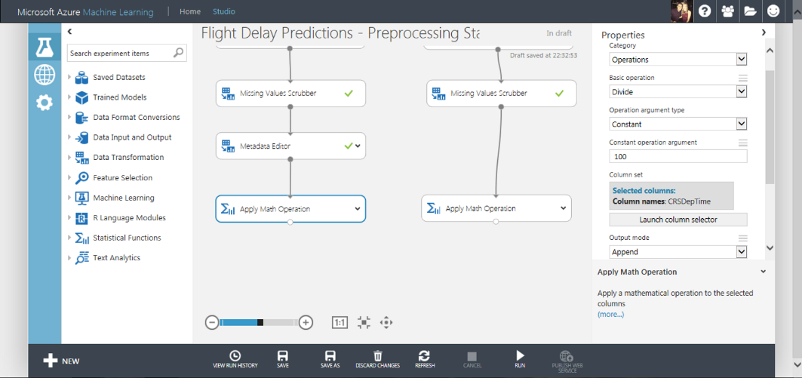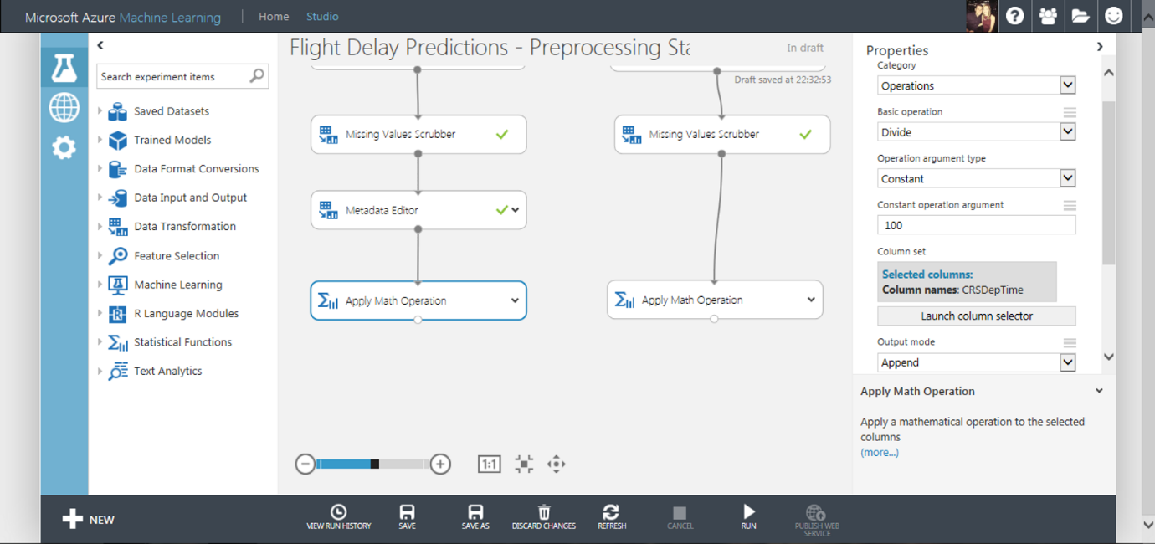

Now do the same operation and apply to the Weather Data branch as shown below:

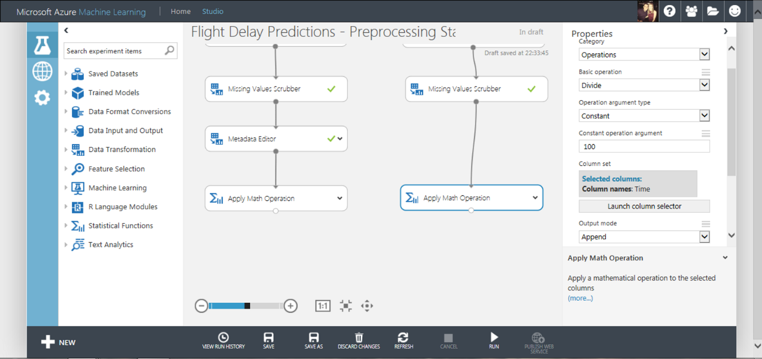



Notice the Output Mode property is set to Append. This will now create new columns with the Math applied and a new name (Divide(Time_$100) and Divide(CSRDepTime_$100)). At this stage make sure you save and run the experiment in order to proceed to the next stage.

Now we will round the time to the hour using the ‘Apply Math Operation’ module, one attached to each branch of the experiment. The properties of each of these modules are set as shown in the images below:

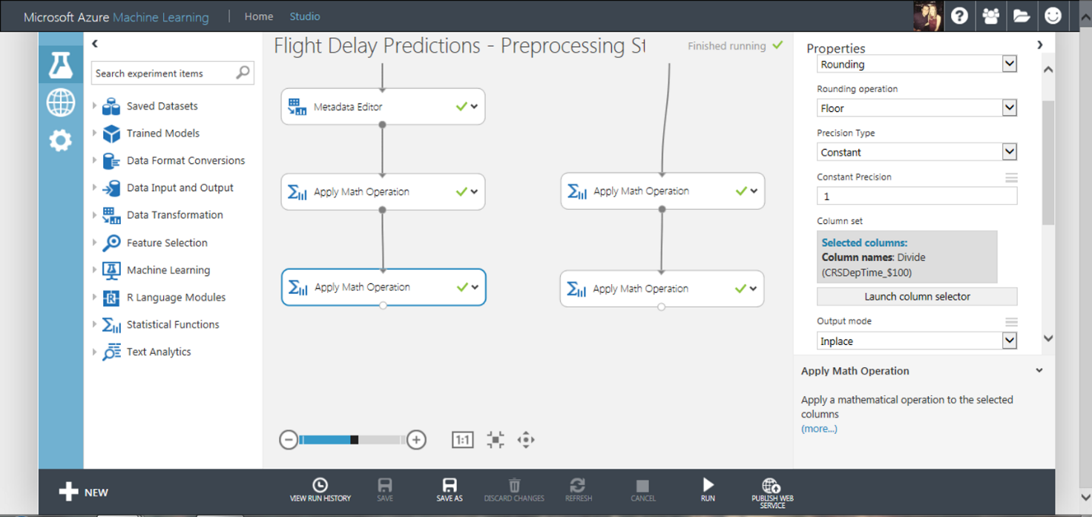Flight Delay Data Branch: Rounding, Floor, Constant, 1. Select the column Divide(CSRDepTime_$100) and output mode as ‘Inplace’.

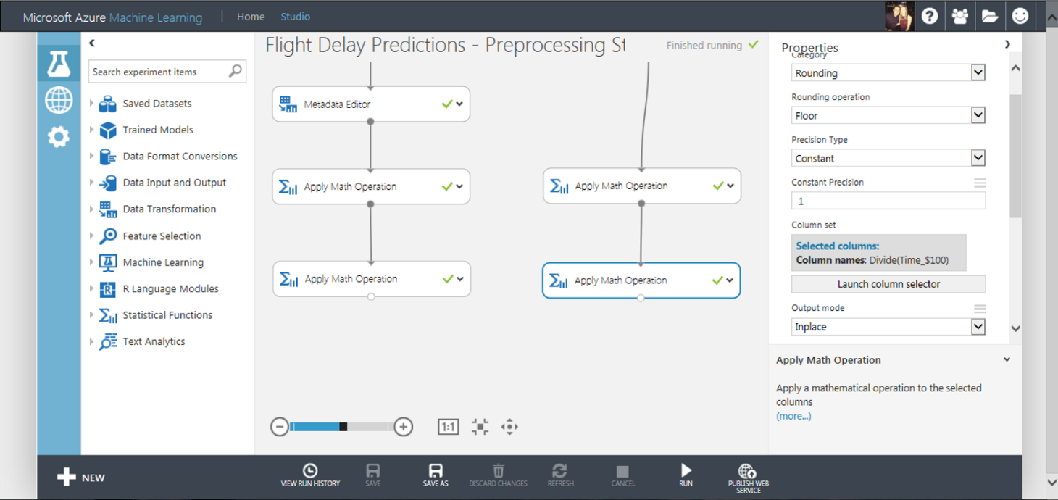Weather Data Branch: Rounding, Floor, Constant, 1. Select the column Divide(Time_$100) and output mode as ‘Inplace’

In the weather dataset there are some duplicate weather data rows and we only want one weather reading for each hour of a day.

Select the ‘Remove Duplicate Rows’ module and make sure that the filter expression is:

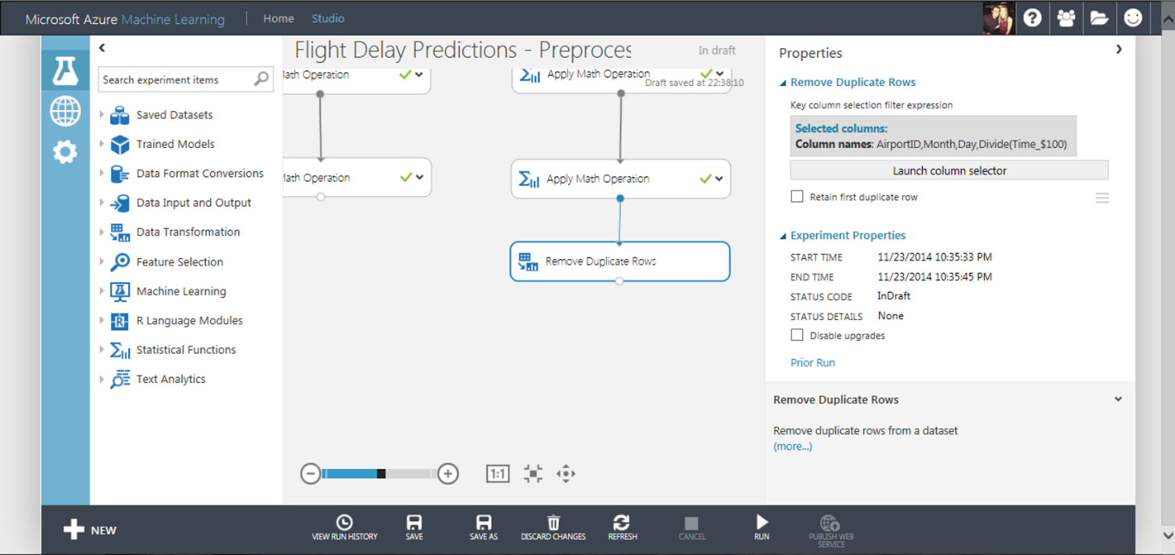**Column names:** AirportID, Month, Day, Divide(Time_$100)

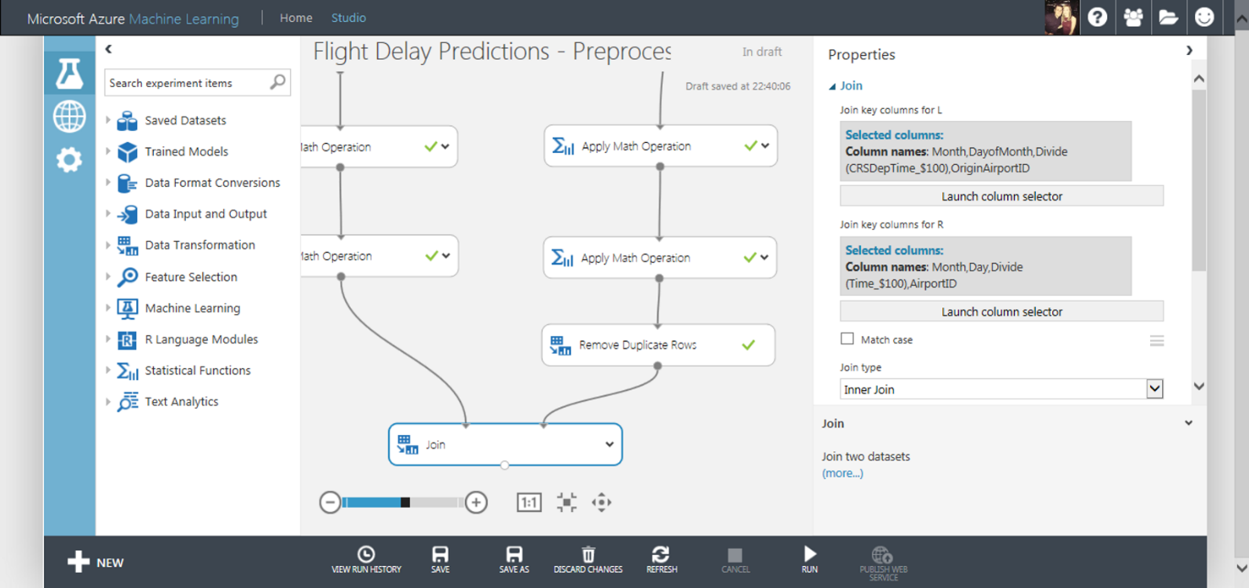Now the data in each set is aligned, we can use the ‘Join’ module to connect the two datasets as shown below

* The columns selected from the Flight Delay Data are Month, DayOfMonth, Divide(CSRDepTime_$100), OriginAirportID
  + **\*NOTE:\*** make sure “Allow duplicates and preserver column order” is Ticked
* The columns selected from the Weather Data are Month, Day, Divide(Time_$100), AirportID
  + **\*NOTE:\*** make sure “Allow duplicates and preserver column order” is Ticked
* 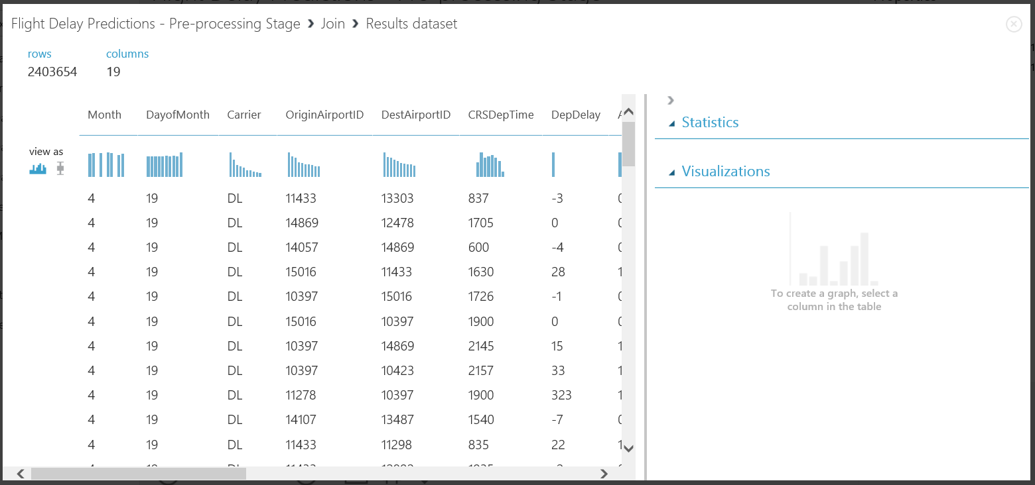We are not matching on case and the Join Type is Inner Join

The results of joining the datasets are shown above and now we have manipulated the data into a clean format and will be able to input this data as training data into a model to learn.

After joining the data above, we find we have many forms of the time column all in one dataset. Therefore we need to remove these data columns before training our data. We are saving both time and processing cost by doing this.

Drag a project columns module onto the workspace and choose the following properties listed below in the ‘Launch Column Selector’ functionality:

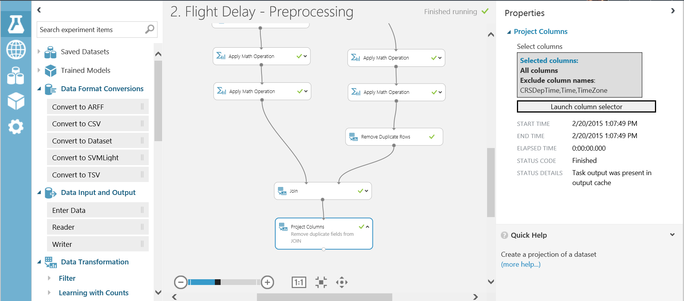‘All Columns’ -> ‘Exclude’ -> ‘CSRDepTime’ ‘Time’ and ‘TimeZone’

At this point in the experimentation process we have a clean set of data that can be used to train and evaluate a model. We are moving from the business knowledge domain to the machine learning domain. To predict if a flight is delayed or not based on historical data sets, this experiment is a form of supervised learning and we will apply binary classification models to the data to predict if a flight is delayed or not.

Training the Model

*Check out the ‘Key Word Definitions’ section at the bottom of this document for machine learning term explanations*

Within machine learning we say that the data is a feature or a label. A label in the dataset is a column that tells us the ‘known truth’ for that data entry. This is the column we pass to our algorithms and say, learn from the historical data the patterns present that mean this label is correct. The other data in the set to be learnt from, are called feature columns. Some features will be more impactful than others, however we will see this later.

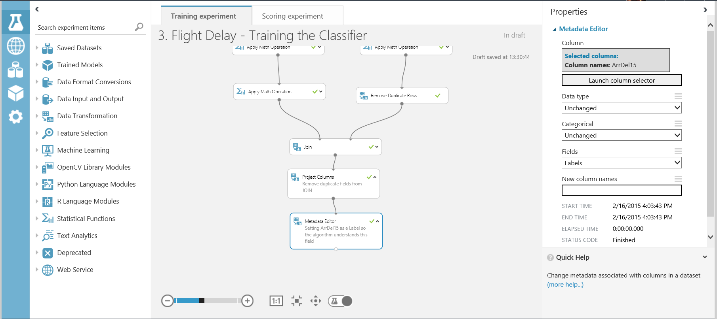In order for Azure ML to understand what the labels and features are in our dataset, we must tell it using the Metadata Editor module. Connect the Metadata module to the Project Columns output port and select the ArrDel15 column. In this lab we want the classifier to learn the behaviour of ‘ArrDelay15’ therefore in the ‘Fields’ parameter select ‘Labels’

Finally we need to tell Azure ML that the rest of the columns in the set are features and it should find patterns in this data that effect the ArrDel15 column. Select all columns and ‘exclude’ columns names ‘ArrDel15’ as shown below.

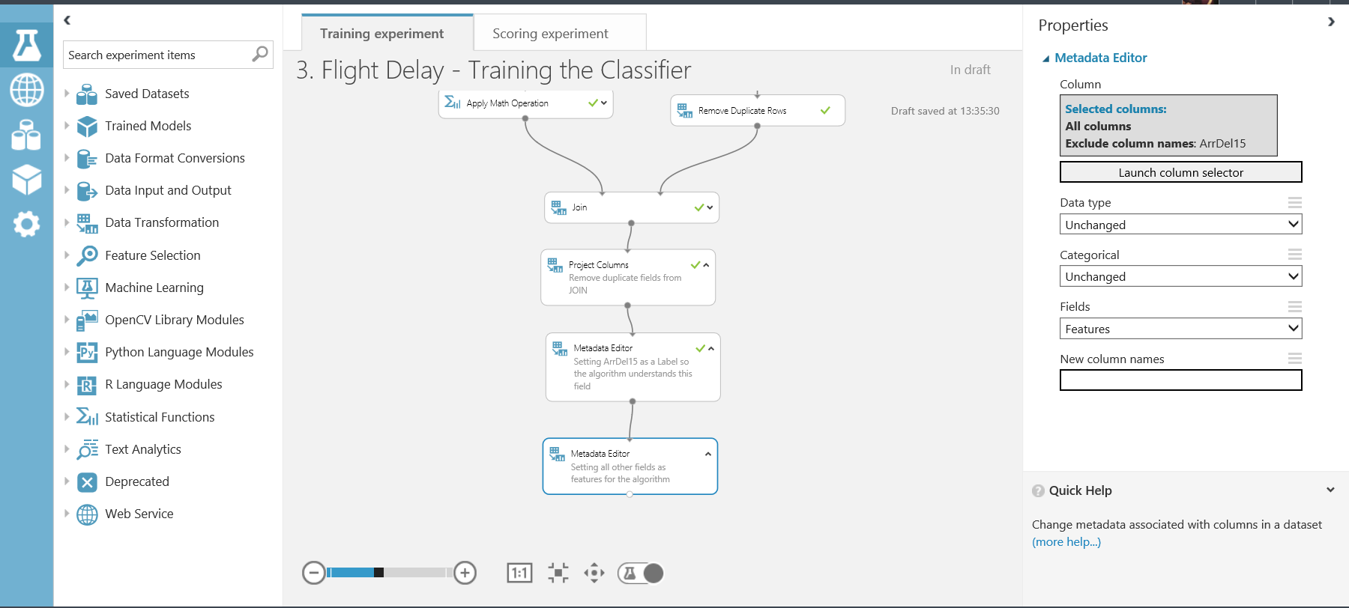

Next we will split the data into 3 sets; training, validation and test data. The sets will have a 60:20:20 split respectively. The data is split into 3 parts so that some data is used for training, some used to validate the trained model when scoring. Finally the test data will be set aside until we have our best trained model in order to check for over-fitting of the data.

Drag and drop the first split module onto the workspace. Connect this to the project columns module and set the ‘fraction of rows in the first output dataset’ field to 0.8 (80%)

Place another split module on the workspace and split the training/validation set using 0.75 (75%). Creating overall a 60:20:20 split.

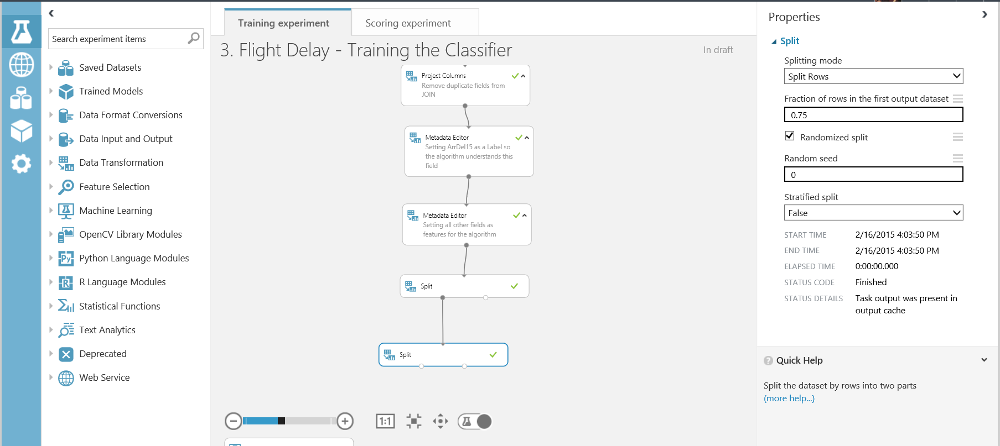

After splitting the data, choose a classifier from the module list in the left hand menu. There are many classifiers depending on your prediction problem and the type of learning you want to use.

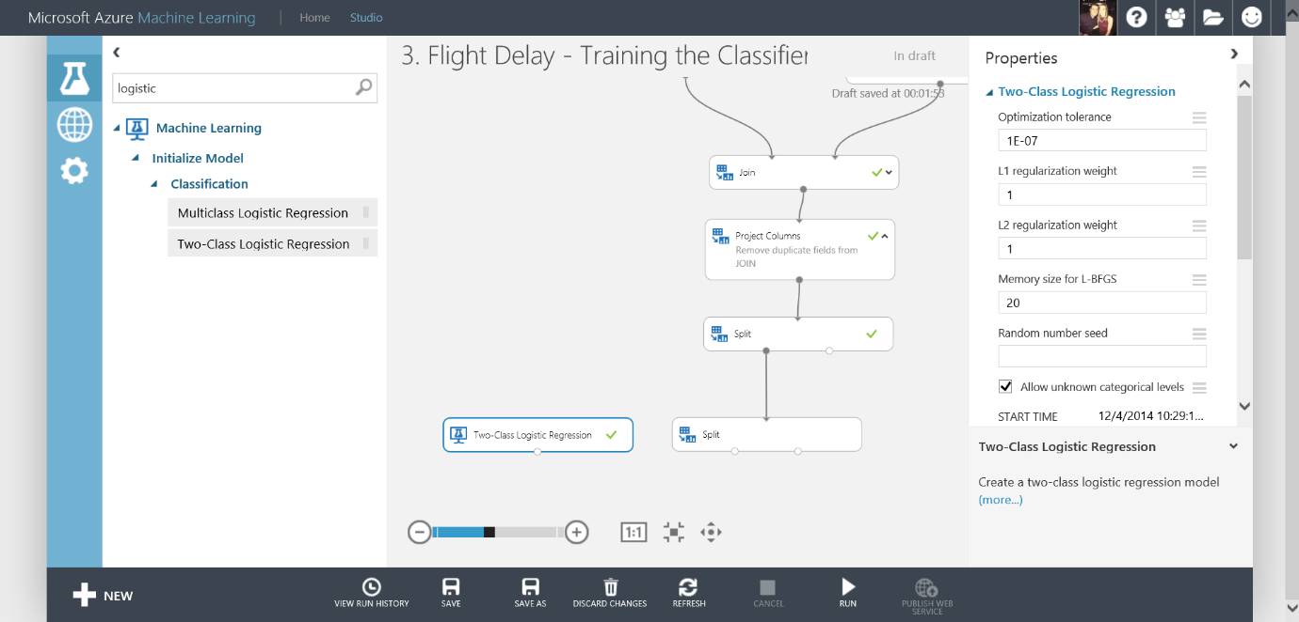For this lab we will use the ‘Two-Class Logistic Regression’ classifier module. Drag and drop this onto the workspace.

Next, drag and drop a ‘Train Model’ module onto the workspace. Connect the classifier to the left input port and connect the training data to the right input port.

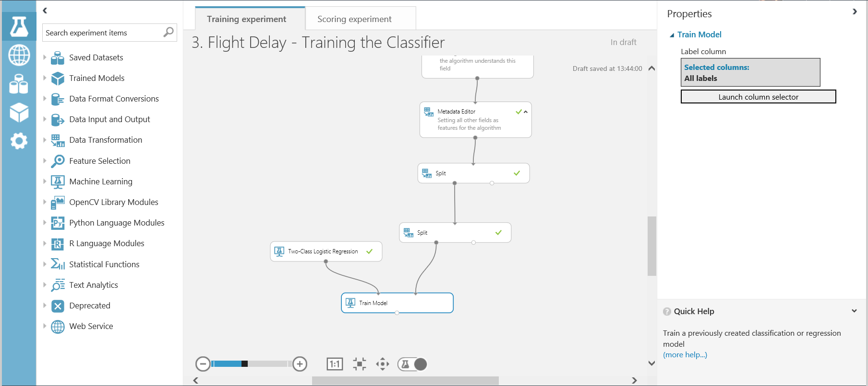Select the Train module and look at the properties menu. Click on the ‘Launch Column Selector’ module and you can choose the column you want to learn (our label) by selecting ‘Include’ and the next drop down ‘All Labels’

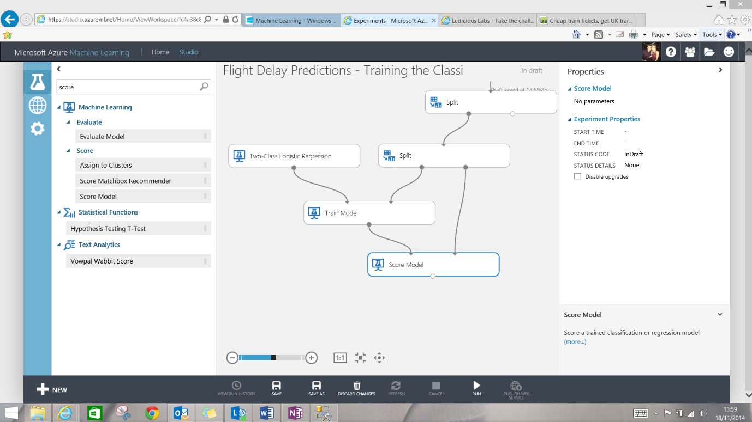Next use a ‘Score Model’ module to score the trained classifier against the test data. There are no parameters to set for the score module.

Using the ‘Evaluate Model’ module will evaluate the performance of the trained classifier on the test dataset. By using the test dataset you are providing the trained classifier with previously unseen data and asking it to 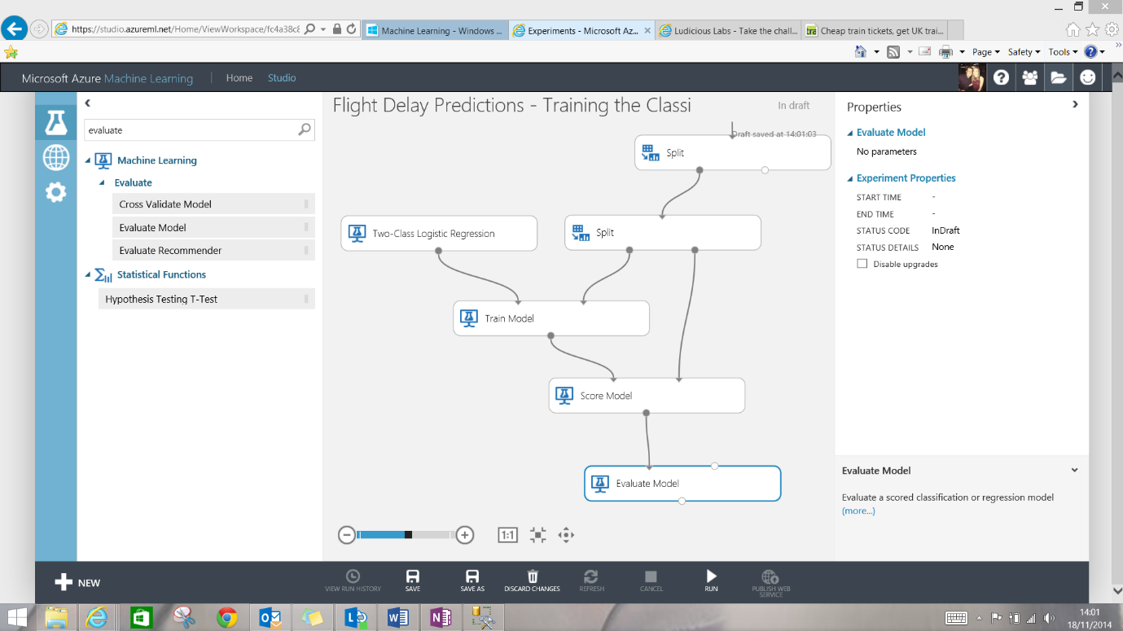classify it correctly based on what the classifier has learnt.

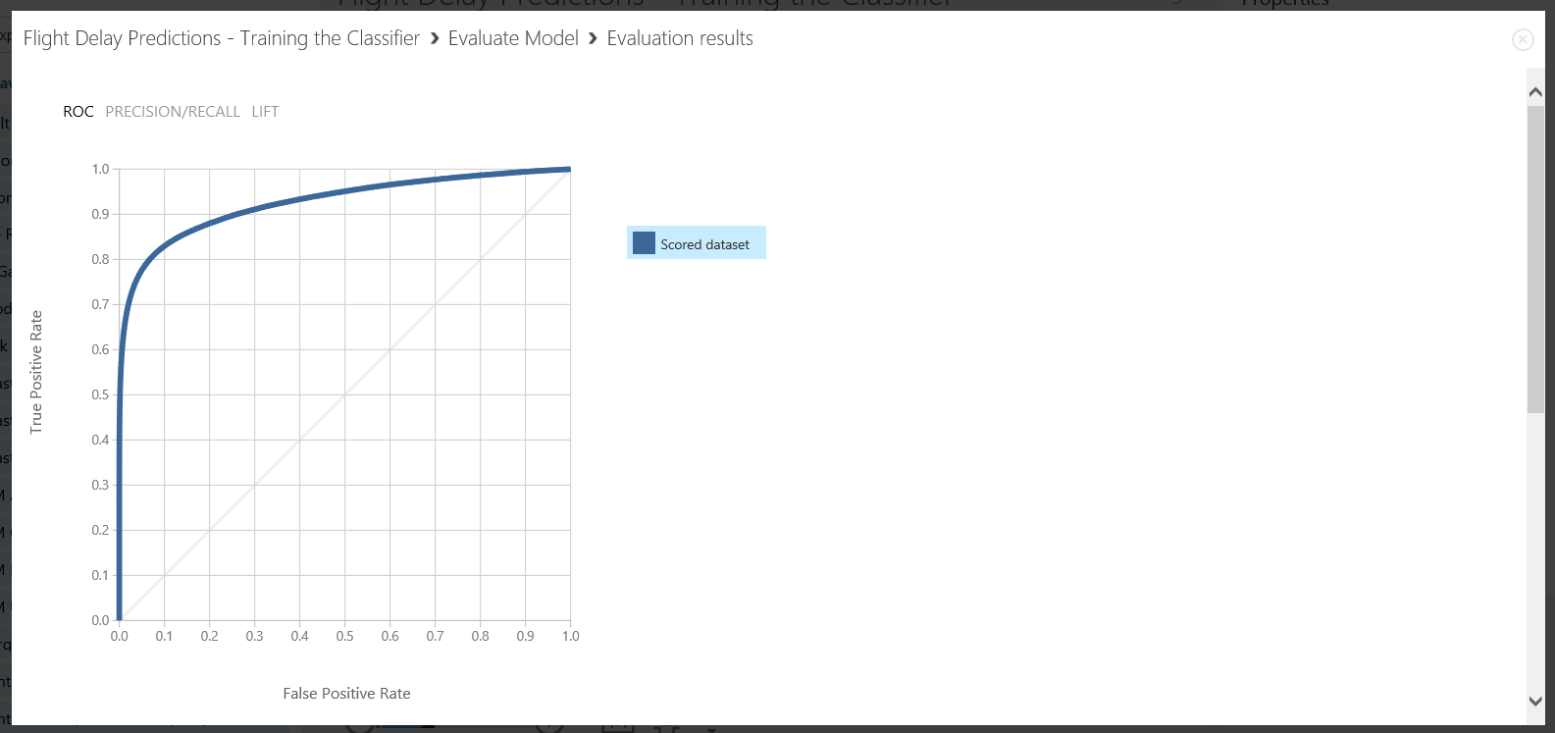This produces visualisations including ROC curves and accuracy, precision, recall metrics etc.

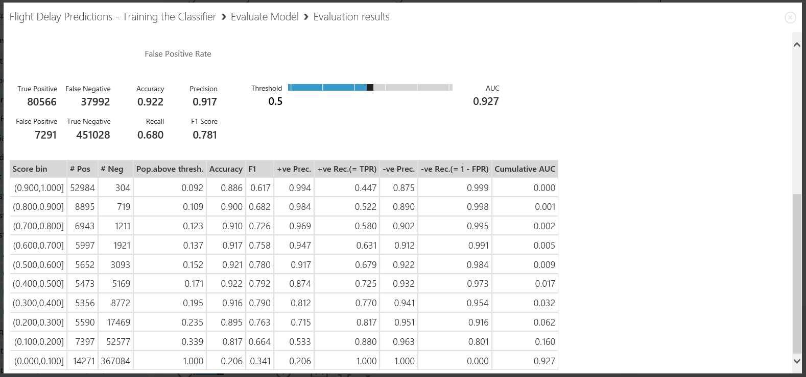

Currently you have one classifier and its evaluation metrics. A great feature of Azure ML studio is that you can very easily compare multiple classifiers.

Optimizing Classifiers

In this section we will compare the Logistic Regression classifier against the Boosted Decision Tree classifier to see which one best suits the data for our prediction.

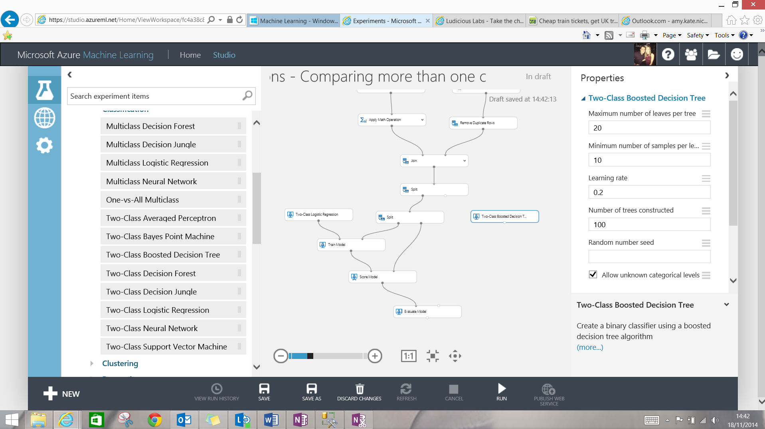Find the ‘Two-Class Boosted Decision Tree’ classifier and drag this onto the workspace. Notice in the properties pane there are many parameters you can set for each classifier. It is hard to optimise parameters manually, we will see later on in the lab how to optimise the parameters.

Next add a ‘Train Model’ module, connect this to the Boosted Decision Tree using the left input port and then connect the training data set to the right input port. Set the column to train on the same column as the previous classifier, ‘Include’ -> ‘All Labels’

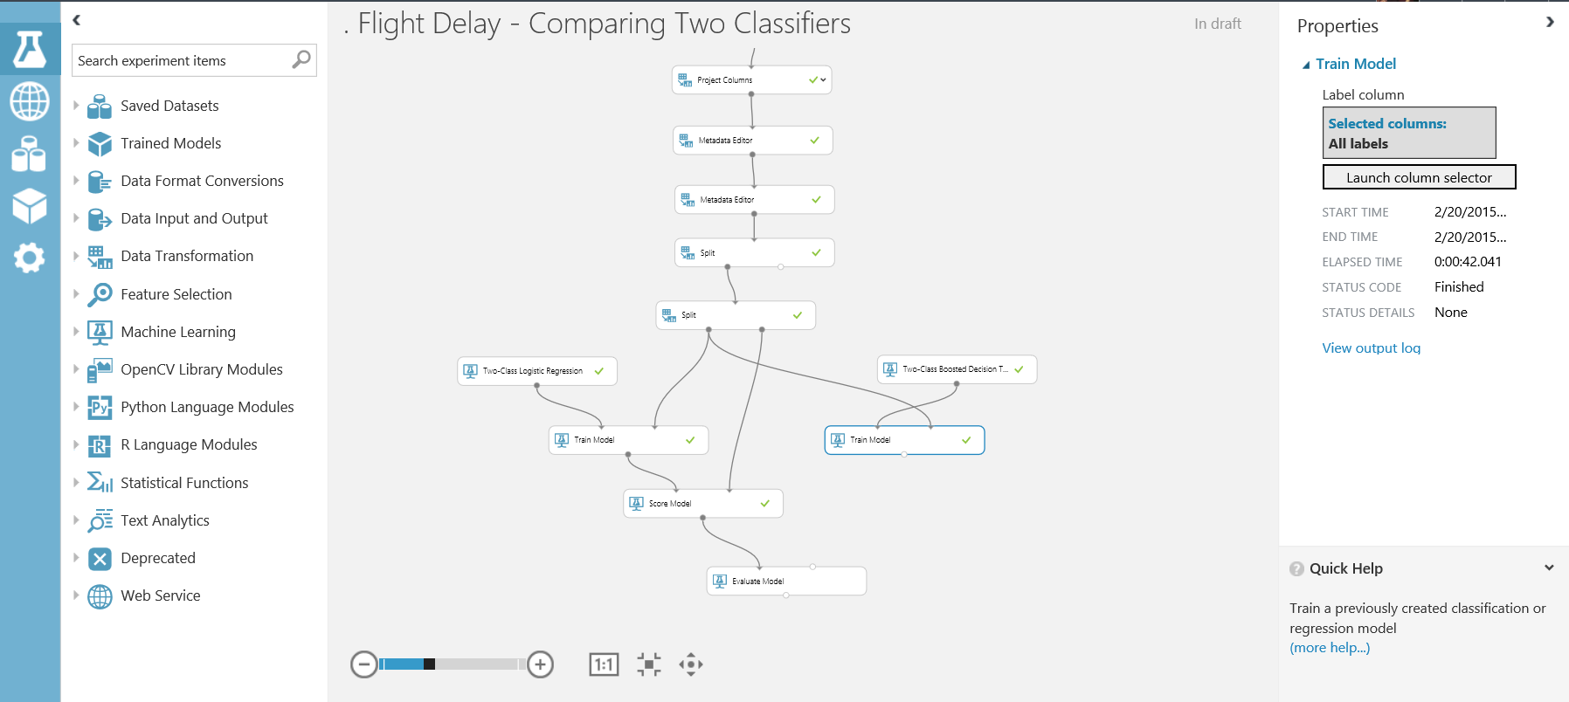

Connect a ‘Score Model’ module to the Train module and the test set. Finally connect the ‘Score Model’ module for the second classifier to the second input port of the ‘Evaluate Model’ module as shown below

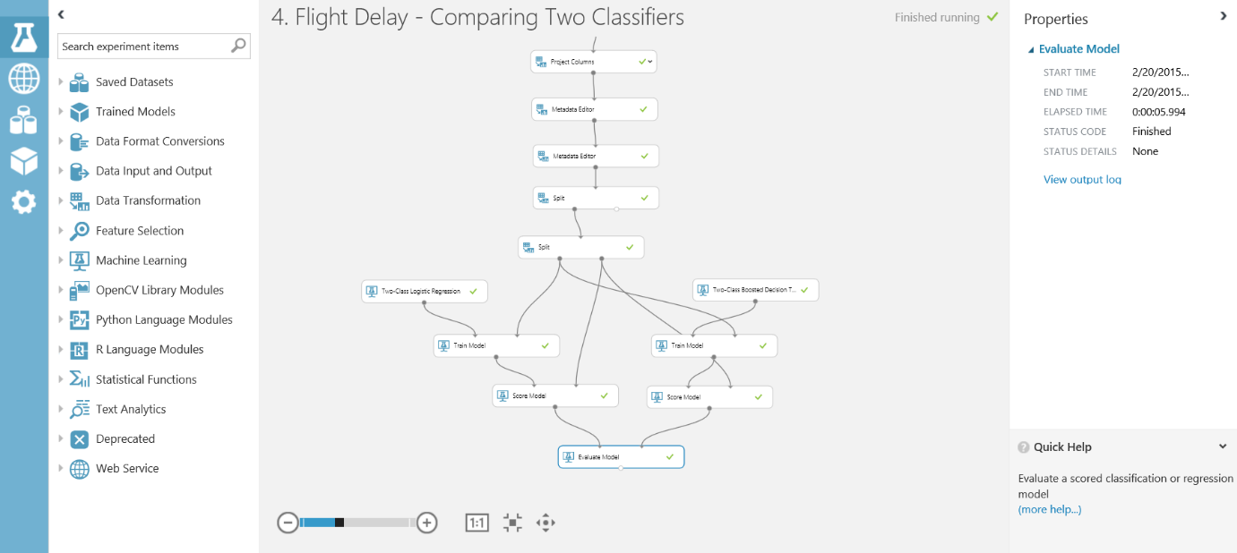

Comparing the two classifiers on one graph shows us the Boosted Decision Tree ROC curve and accuracy is a slight improvement on the Logistic Regression classifier

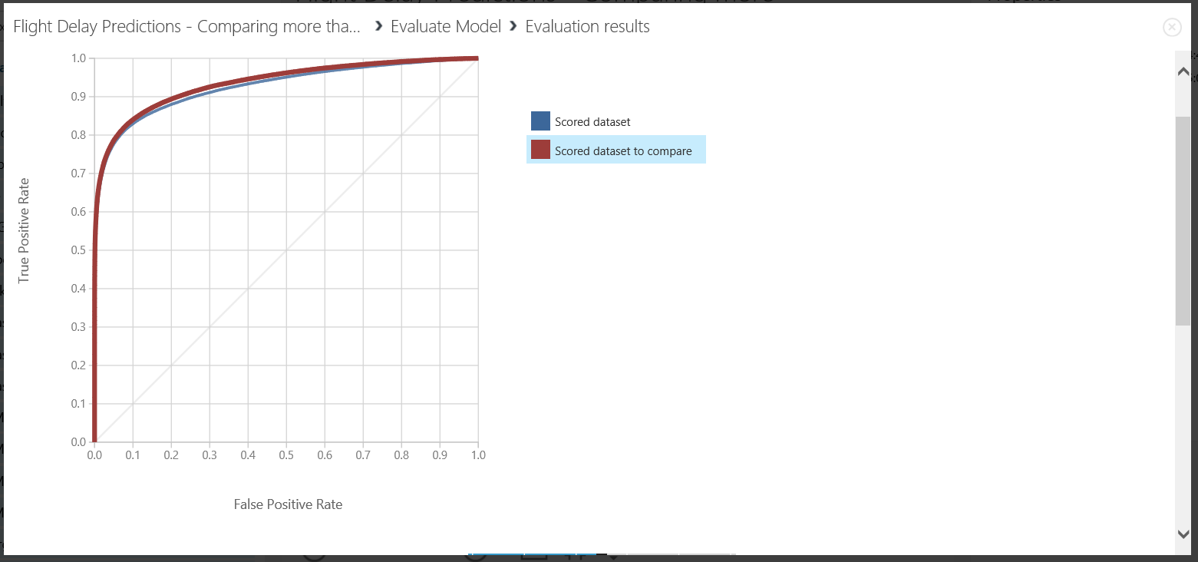

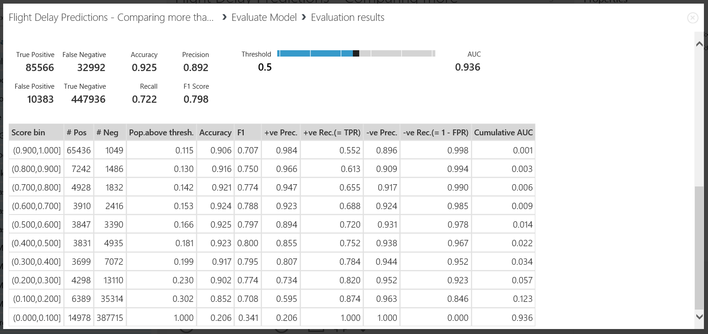

The principle shown above could be applied to more classifiers. You could compare 2, 3 or even 4 classifiers at the same time to see which classifier best suits your data and problem.

Another interesting feature in Microsoft Azure Machine Learning is the ‘Filter Based Feature Selection’ module. This module allows you to select a set of all features; using a selected heuristic; to use in model construction. Now search for the feature selection module and drag it onto the workspace. This module will fit in just before we split the data to then train the various models.

Set the parameters as shown below:

* **Feature Scoring Method:** Chi Squared
* **Target Column:** ‘Include’ -> ‘All Labels’
* **Number of Desired Features:** 7

The chi-squared ranking of features in a two class problem finds the features which differ the most between the two classes. Therefore finding the most significant features that allow you to predict if a flight is delayed or not.

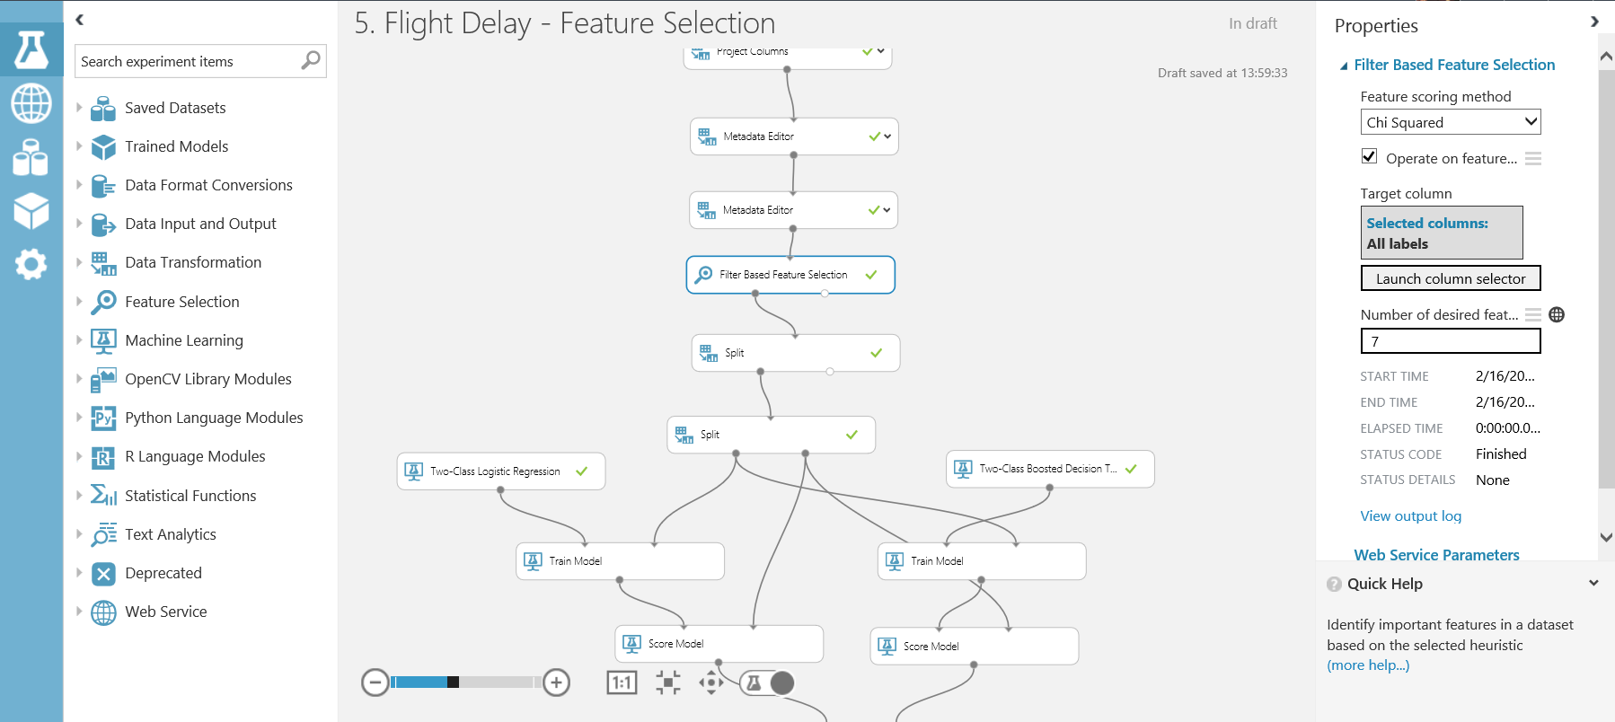

Now we can see the top 7 features that distinguish the two classes (delayed or not) from the right output port of the ‘Filter Based Feature Selection’ module.

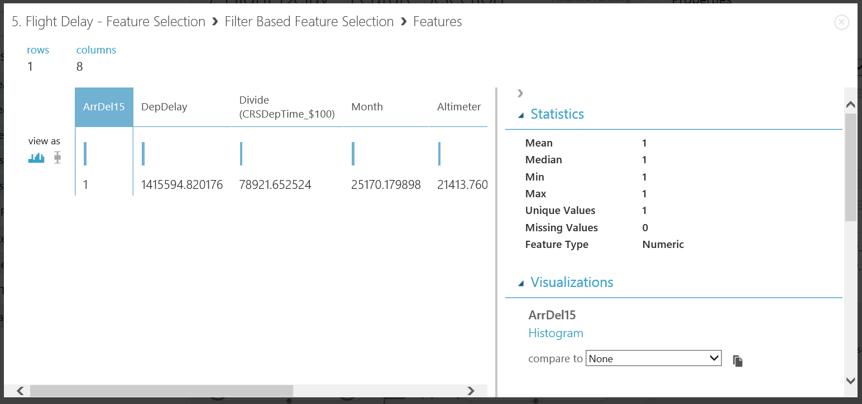

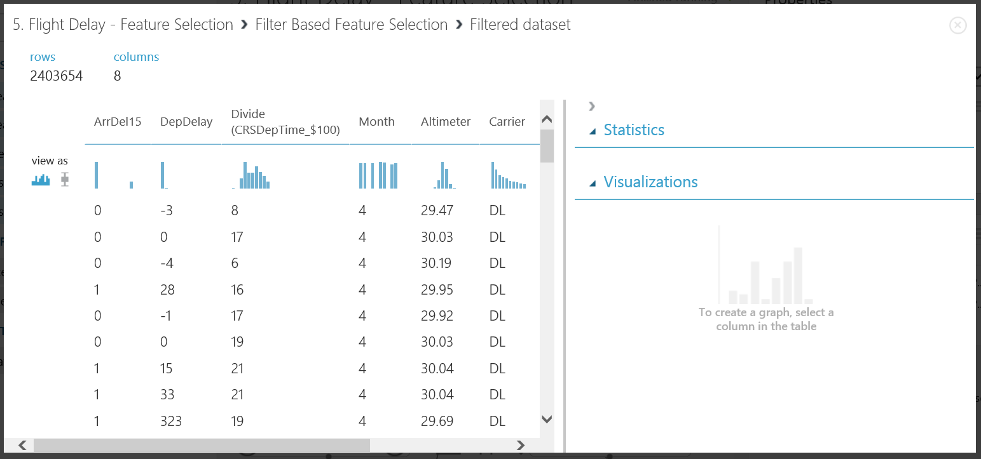From the left output port of this module we can carry on the experiment with a filtered feature dataset.

Feature selection has both immediate and future advantages and disadvantages. For example; because you are cutting down the amount of features, you are cutting down the amount of data, which leads to the amount of intricate patterns the model is able to learn is reduced. The result of this change is potentially a lowered accuracy on your validation set, however for future previously unseen data the model may perform better and over-fitting the data is reduced. Another advantage is, less data leads to reduced processing time.

Finally to optimise our classifier solution we can use a module called ‘Sweep Parameters’. This module allows you to determine optimal parameter settings for a specified classifier.

Drag and drop a sweep parameters module onto the work space and set the parameters as shown below. This module has 3 input ports and 2 output ports. Plug into the input ports, your chosen classifier, in our case this is the Two-Class Boosted Decision Tree. The second and third input ports you connect the training and test datasets respectively

* **Parameter Sweeping Mode:** Random Sweep
* **Max number of runs:** 10
* **Random Seed:** 0
* **Selected Column:** ‘Include’ -> ‘All Labels'
* **Metric for Measuring Performance:** AUC and Mean Absolute Error

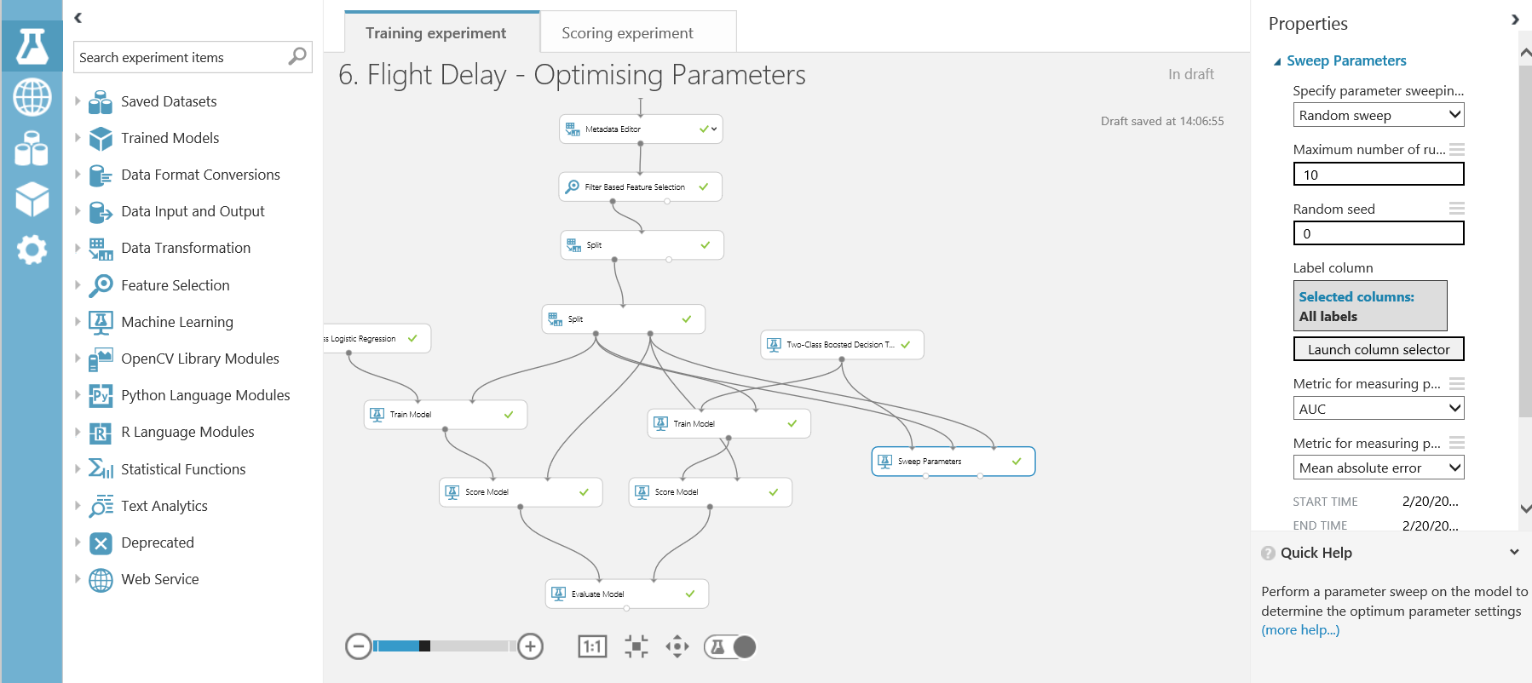

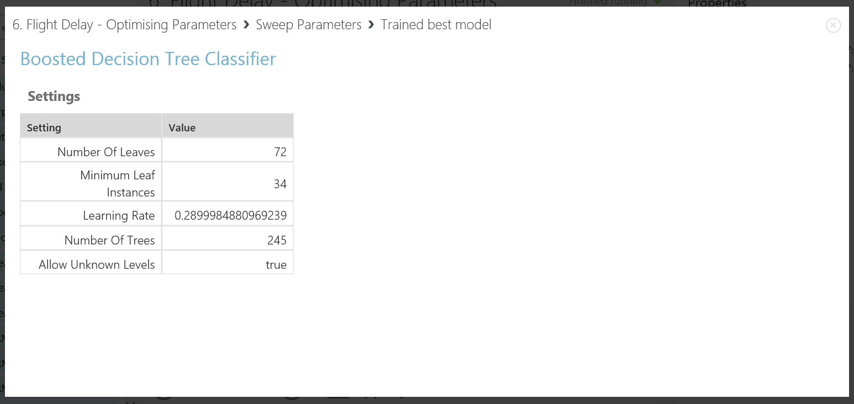The right output port of the sweep parameters module now contains the best trained model. This model has optimised parameters for the total sweep runs completed. Connect this to a score module and the final unused test data set. This will now validate the AUC and accuracy measurements on data the classifier has never seen before.

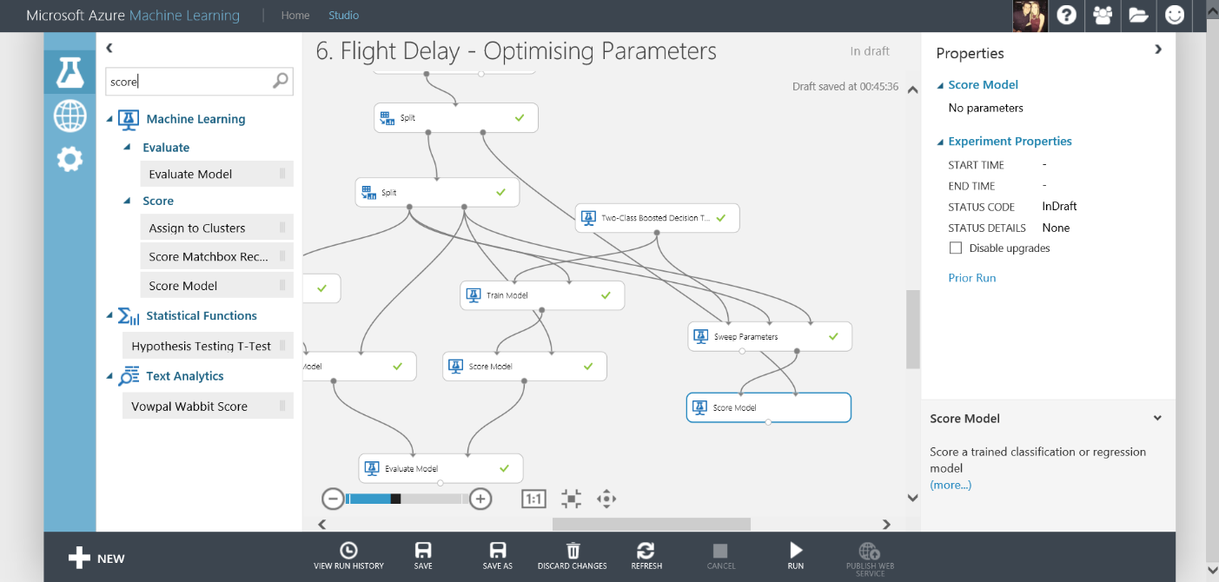

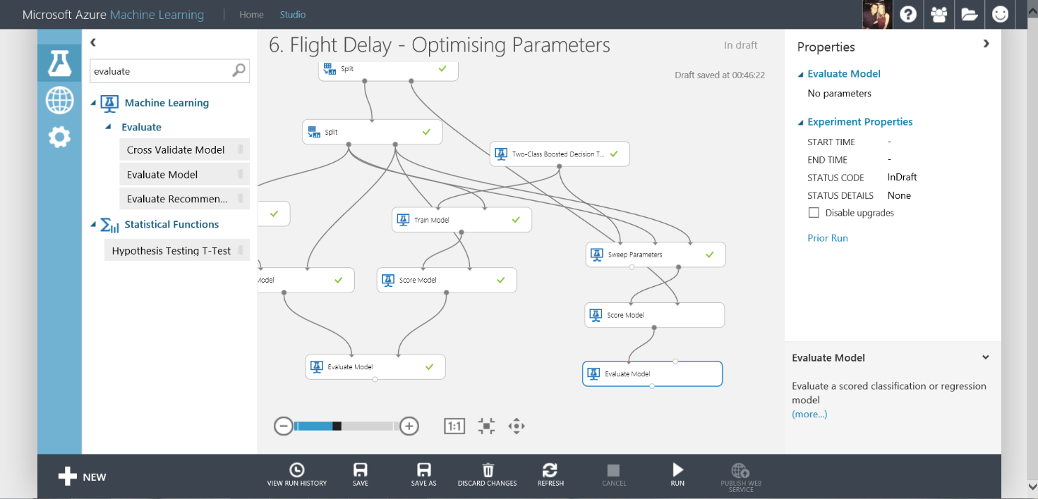Finally connect an evaluate module to the score module and run the experiment

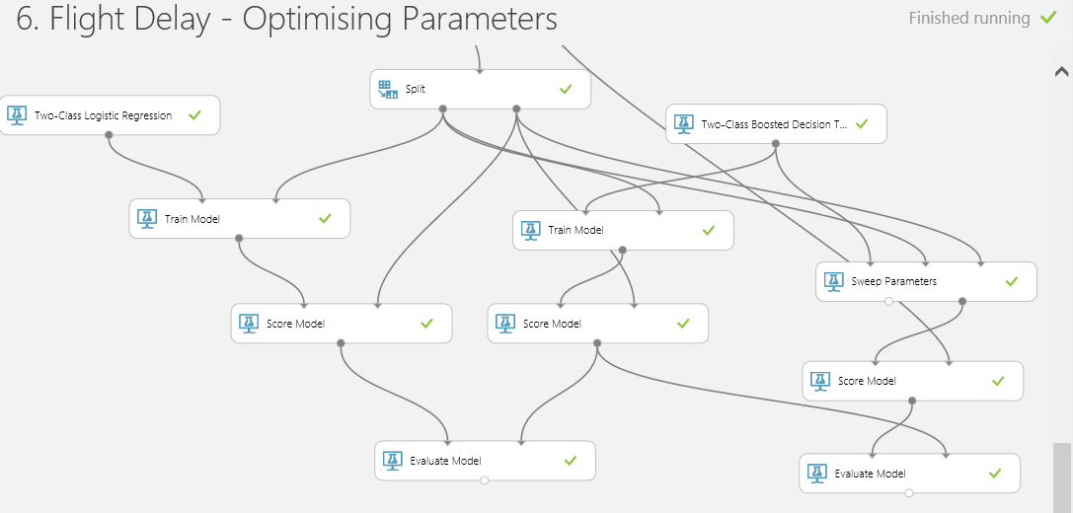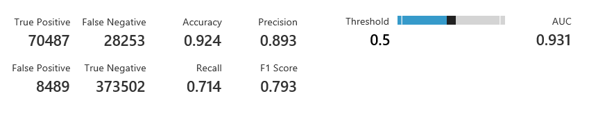If you connect the output of the Boosted Decision Tree branch Score module to the right input port of the evaluate module in the sweep parameters branch and then visualise the results, it shows a very slight increase in accuracy and AUC due to the optimisation of parameter values.

We have cleaned our data, we have trained a classifier and we have re-iterated over our experiment to improve the accuracy of our classifier. Now we want to use one of Azure ML’s key features – operationalising the classifier. In order to create a web service for this classifier we first want to create a Scoring Experiment. You can then publish the scoring experiment to the ML API service to make it available for other users or applications to use as a web service or a REST endpoint.

Creating a Scoring Experiment

This may sound like a hard task, however once your best classifier model has been run and there are green ticks by each module you will see a button on the toolbar at the bottom of the screen become active

**\*Note:\*** Make sure you select the module that you want the studio to save as your best trained model. In this case we select the ‘Sweep Parameters’ module.

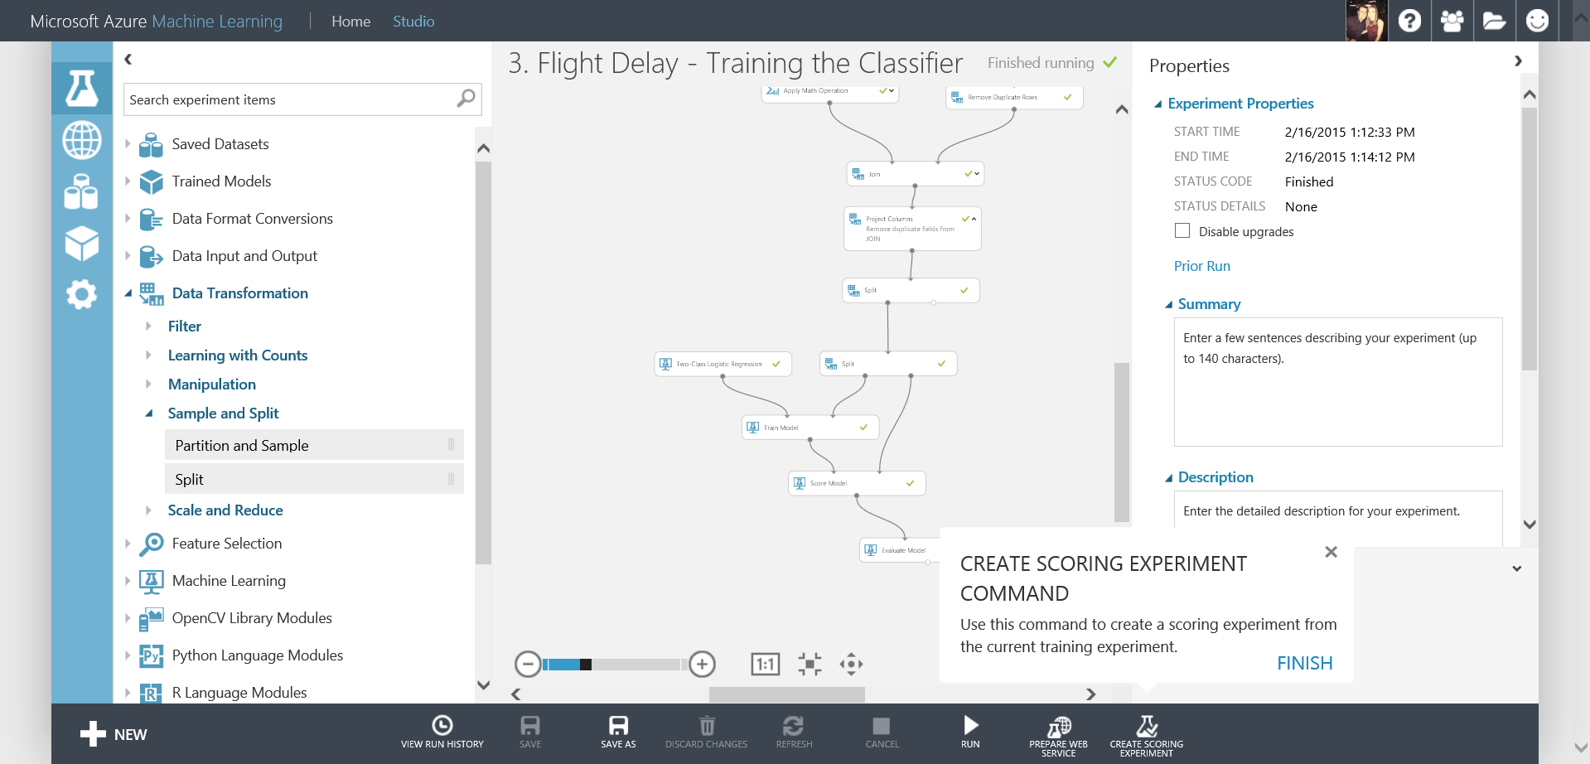

When you first use this feature, it will take you through the process pointing out all the important features shown below.

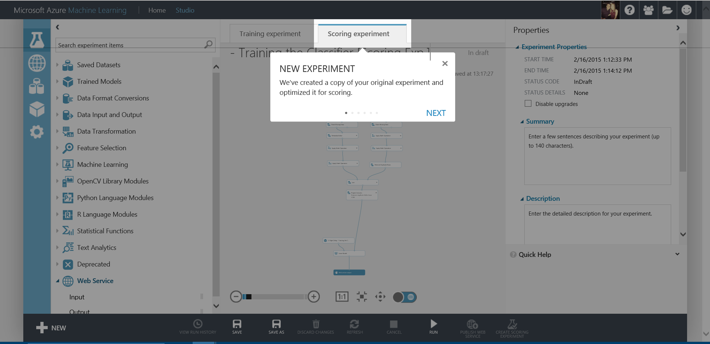After clicking the ‘Create Scoring Experiment’ a new Scoring Experiment tab will appear at the top of the screen with a copy of your current experiment.

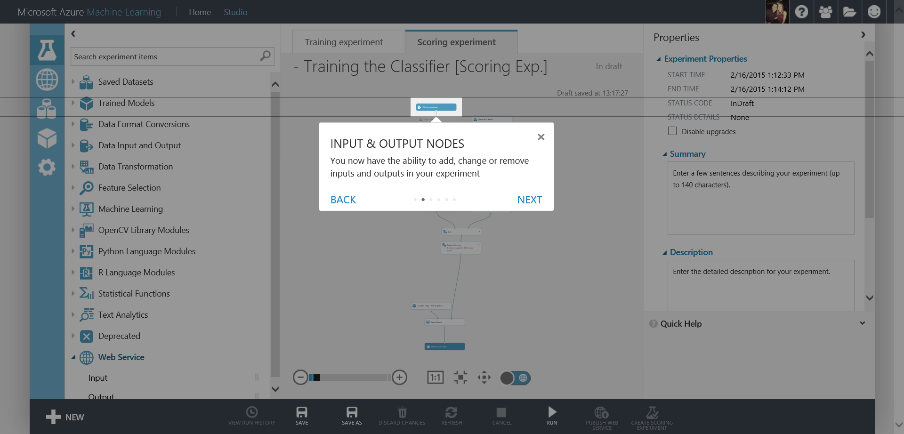Next you will notice some input and output nodes have been added to your experiment. These are the inputs and outputs to your web service visualised.

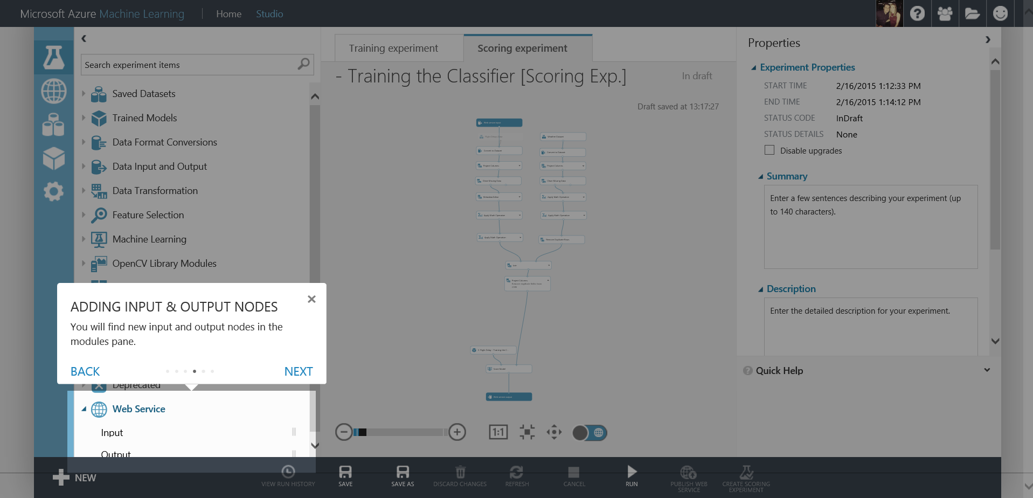It also shows you how you can add them from the modules menu on the left toolbar.

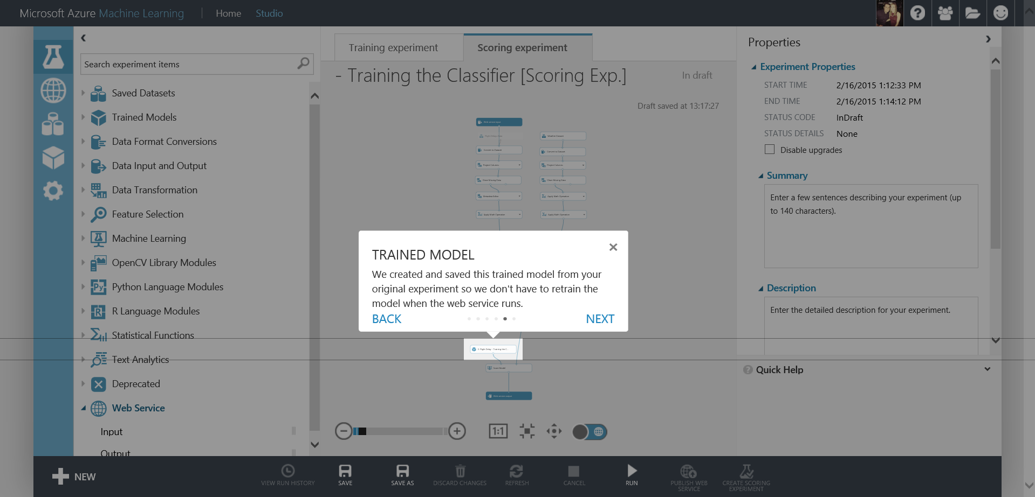Next your best trained will automatically be saved into a module and named relative to the experiment. Another great feature is that Azure ML then tidies up your scoring experiment to only the modules needed as shown below

Now the studio has helped you most of the way there are a couple of actions you need to do before you can publish as a web service.

1. Drag the input web service module from the top of the experiment connected to the flight delay data, down to the score module and connect it to the right input port. This is the part of the experiment you want the web service to start from.
2. Next you want to include a project columns module just above the score model and select All Columns, Exclude, All Labels as shown below. This will remove the value we want the classifier to predict from the web service input (the data asked for from the user)

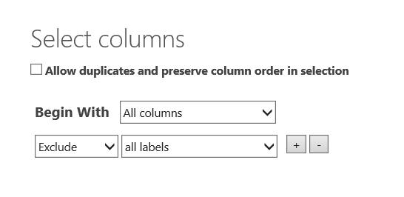

Resulting in the experiment setup below which is ready to create a web service:

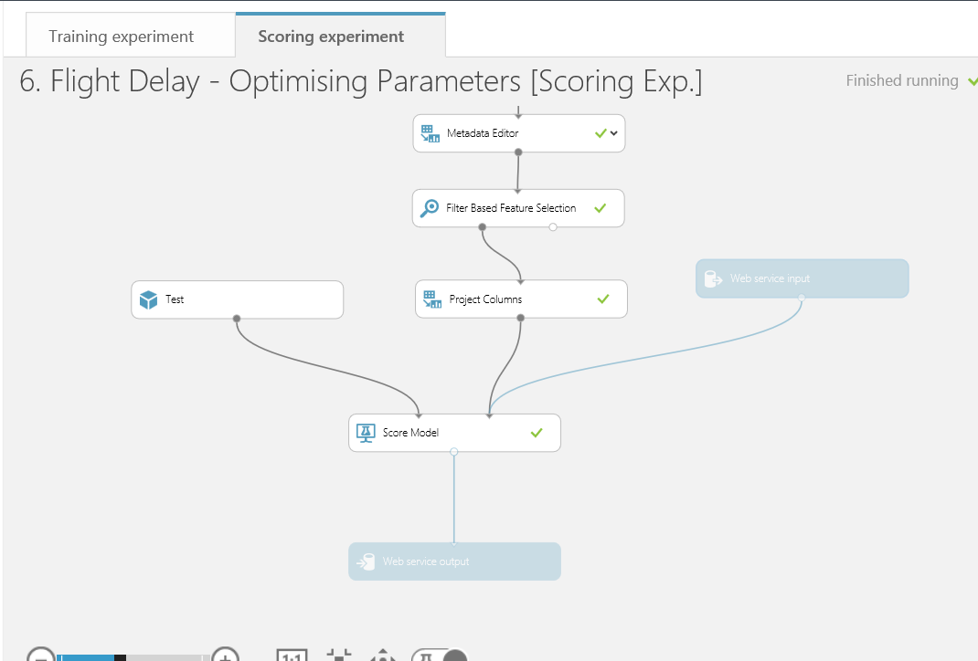

The aim of this section is to publish a Web Service in order to operationalise and deploy a trained model to production. The Web Service consists of a Web API which can be consumed from other applications.

Publish as a Web Service

**\*Note:\*** the best trained model created automatically also appears under the Trained Models category on the left-hand side of the page. This implies the new train model can be used in future experiments as a standalone module.

Now all you need to do it check your experiment has been saved and run. Now the ‘Publish Web Service’ option at the bottom right of the screen is available.

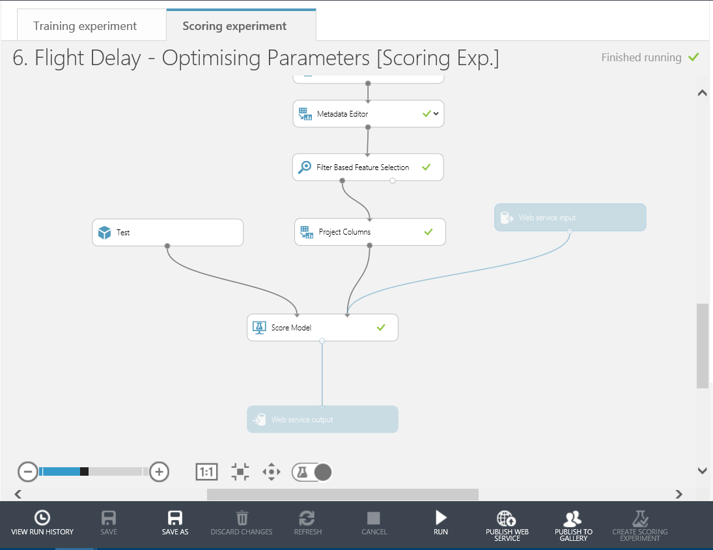

Press the ‘Publish Web Service’ button and then click ‘YES’ to publish a web service for this experiment.

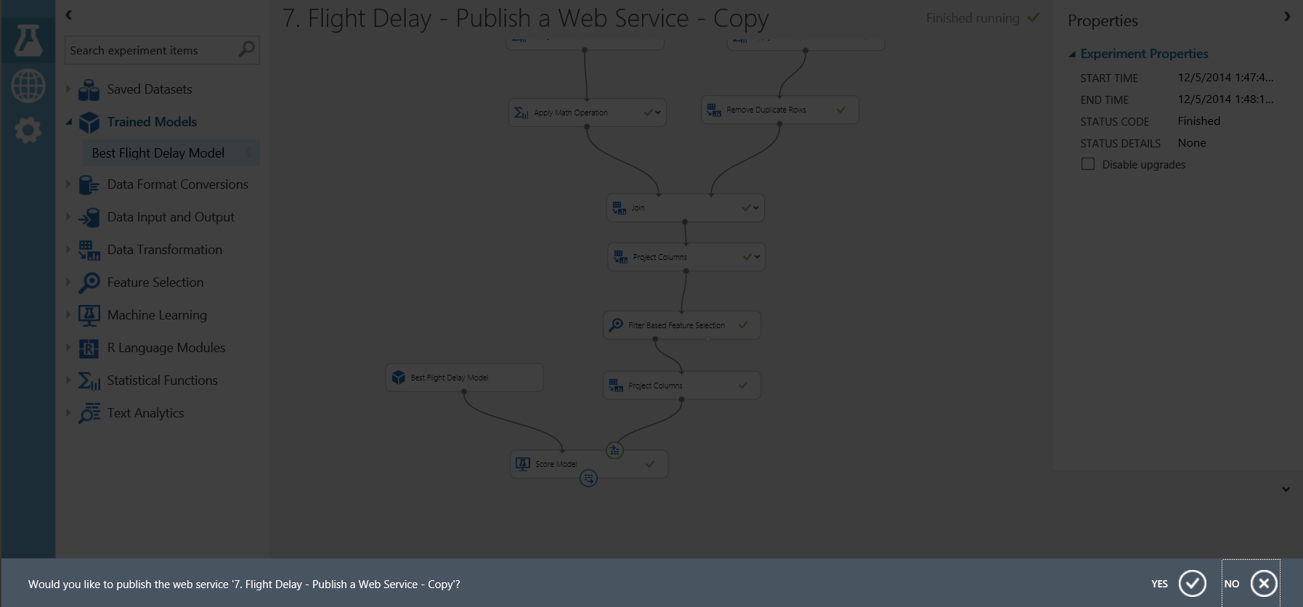

In this section, we are going to look at the published Web Service and try to predict if a flight will be delayed or not based on some input data.

Testing the Web Service

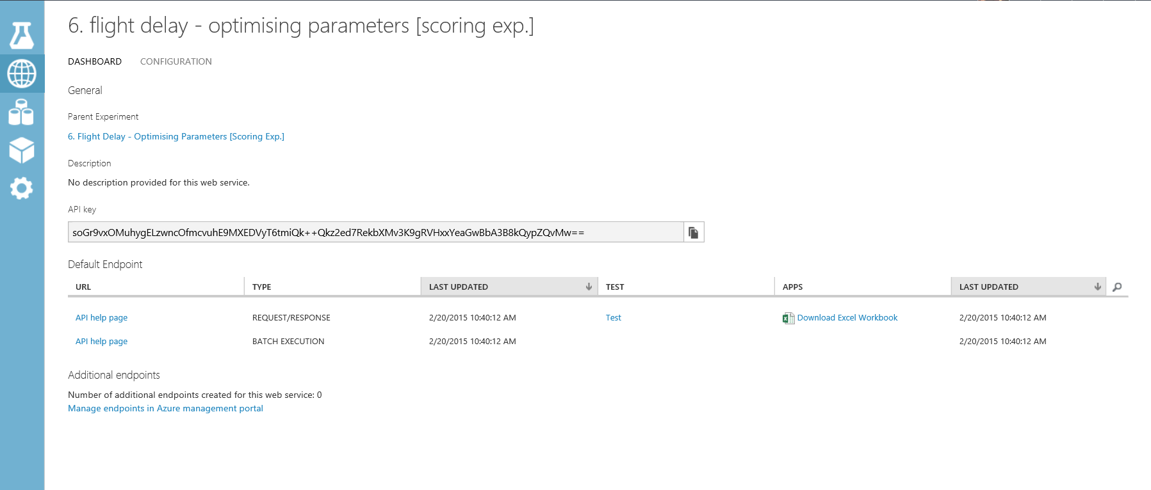After the Web Service is published, we are automatically redirected to the Web Services page for this experiment within ML Studio. In the Dashboard tab, we can see some general information about the WEB API like the API key which is will be used for authorization purposes. There are also help pages available for the two endpoints of the service, a Request/Response endpoint and a Batch Execution endpoint.

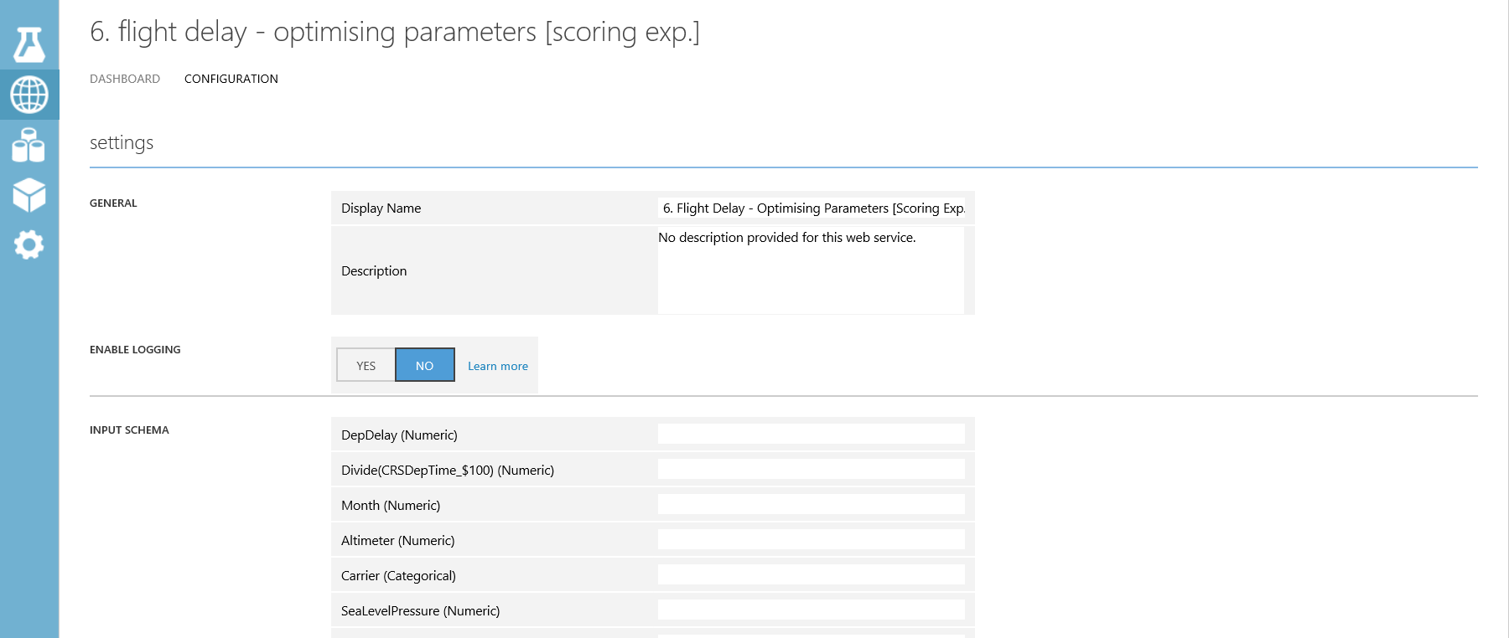The Configuration tab allows you to change the name and description of the Web Service. Additionally, you can add descriptions for the input schema.

On the Dashboard tab there is a link called ‘Test’ for the REQUEST/RESPONSE API. We can use this as a quick sense check to see if our web service is working as expected.

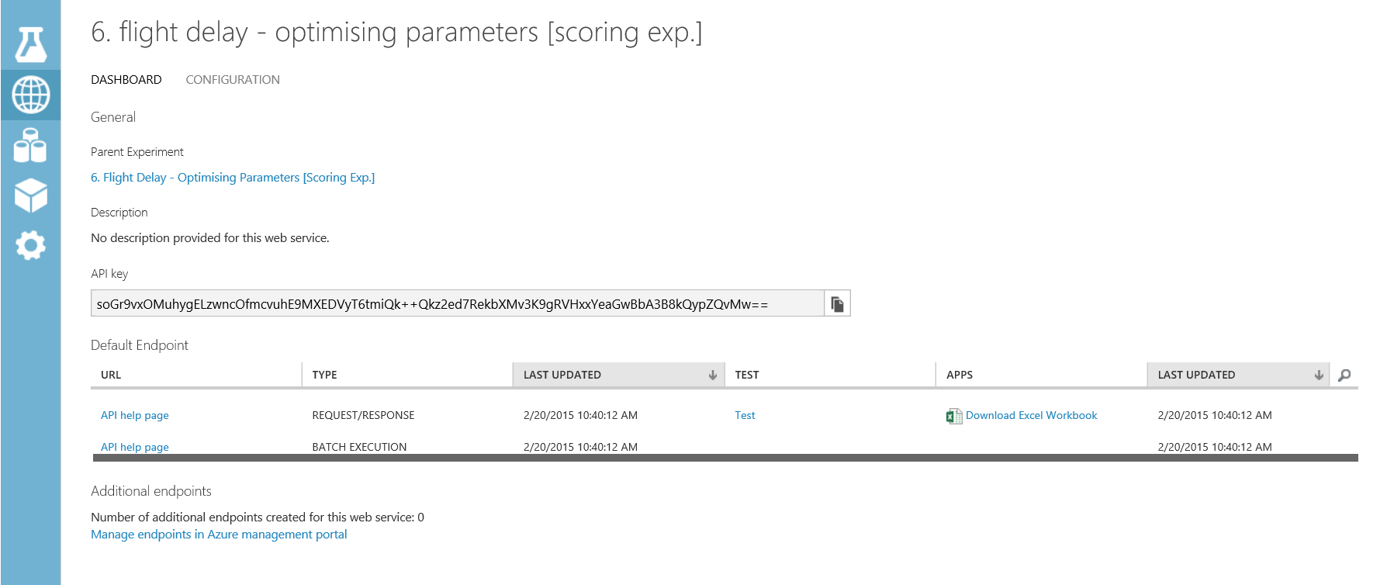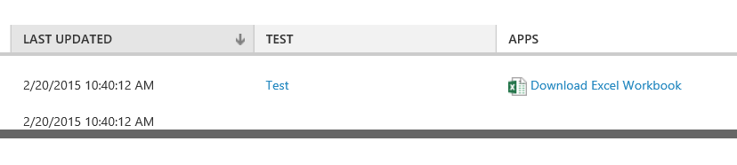

Once clicking on this link enter the following example fields:

* **DepDelay =** 33
* **Divide(CRSDEPTIME_$100) =** 8
* **Month =** 4
* **Altimeter =** 29.6
* **Carrier =** DL
* **SeaLevelPressure =** 30
* **DewPointCelcius =** 1.7

The result you receive back after processing returns a JSON like output with the last two values in the square brackets being the Scored Label and the Scored Probabilities. So in the case below we can say that given the parameters above the classifier has predicted the flight will be more than 15 mins delayed (1) and it is confident in its decision 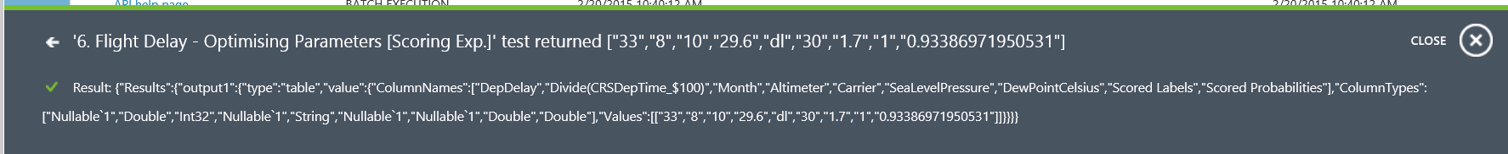(0.93386971950531)

The most recent release of Azure ML includes a community-driven gallery that lets you discover and use interesting experiments authored by others. You can ask questions or post comments about experiments in the gallery and more importantly publish your own!

Publish to the Gallery

The gallery is a great way for users to get started with Azure Machine Learning and learn from others in the community: <https://gallery.azureml.net/>

You can access this gallery via the URL above, or if you are already in the studio you can click the ‘Gallery’ option in the top toolbar:

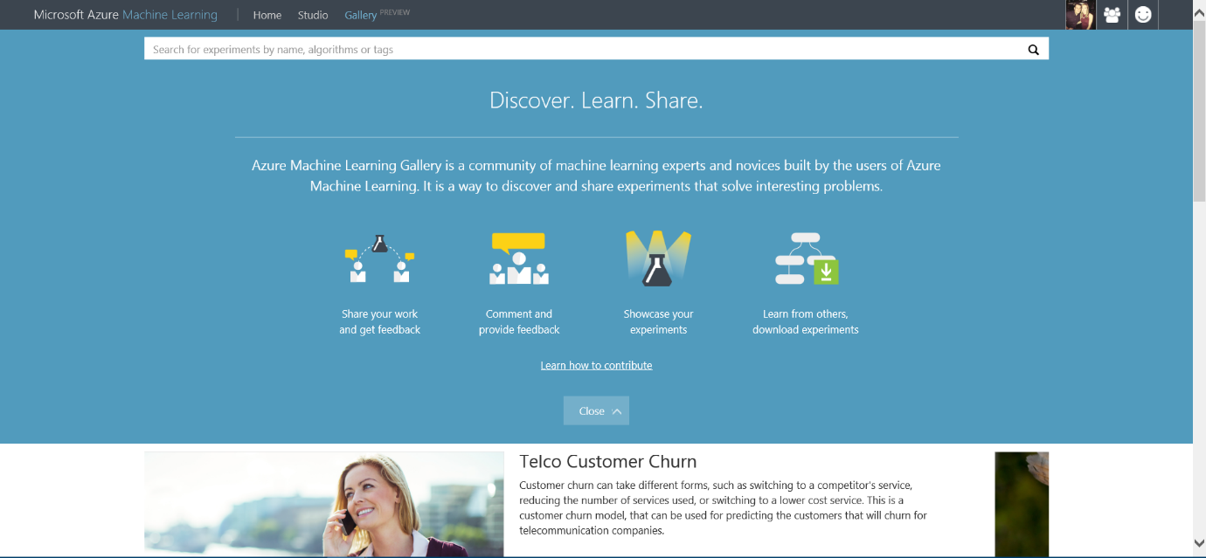

In order to publish your own experiment you need to have met the conditions below:

1. Your have created an experiment in Azure ML Studio
2. Your experiment runs (all green ticks)
3. Your have created a web service and scoring experiment

It is that easy! So everything we have done in this lab has meant that we could publish our experiments in the Gallery. As you will notice in your experiment workspace the ‘Publish to Gallery’ option in the bottom toolbar has become available

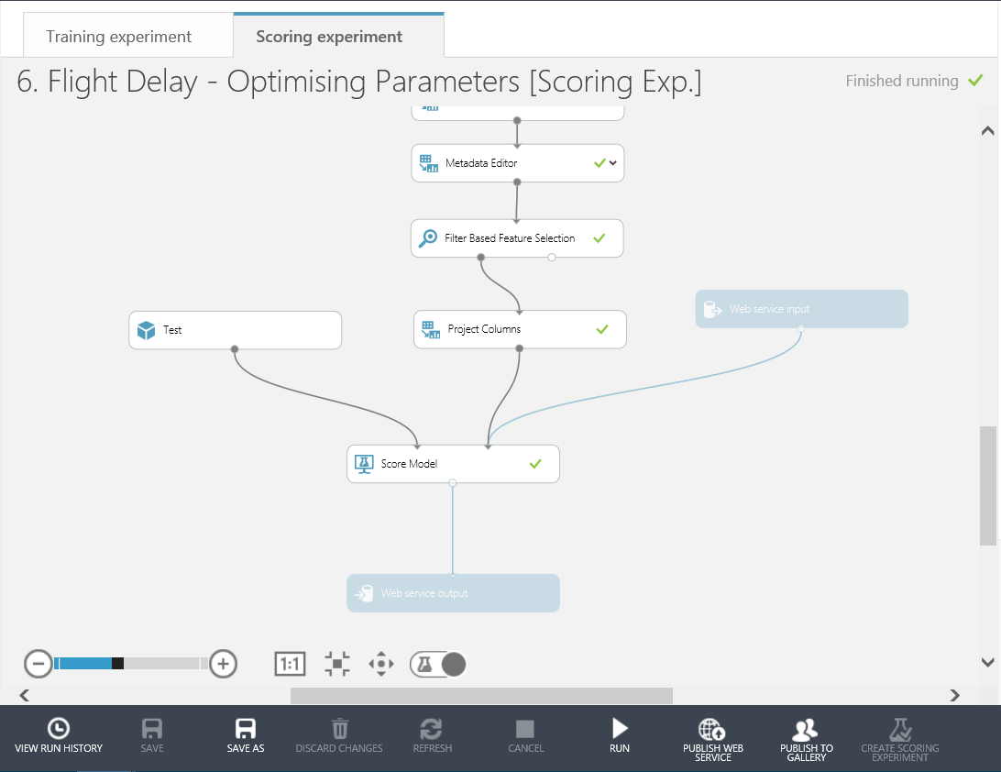

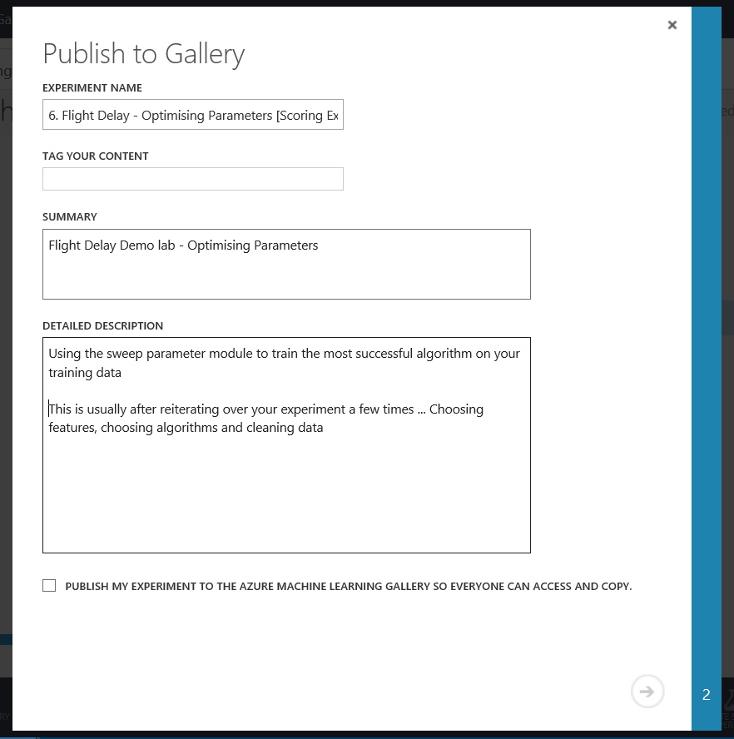This will take you through various stages to Name, give a description, image and tags for your experiment. Then publish it to the Gallery for you.

The experiment we have created in this lab is now available in two forms in the gallery. Check them out here:

Flight Delay Pre-processing stage: <https://gallery.azureml.net/Details/cc618dd8dfb14af0a6354c01ffd606e6>

Flight Delay Web Service stage: <https://gallery.azureml.net/Details/bc3008585f374b62be54d4e57ae8a240>

This lab was intended to introduce you to the basic concepts of Machine Learning such as binary classification, feature selection, training and testing a model and using Azure Machine Learning. A web service was created to operationalize and deploy the model for production.

Conclusion

**Next Steps:**

Check out the UK Data Developer page on MSDN here:

Check out the Azure ML Gallery and download and edit/run other types of machine learning experiments: <https://gallery.azureml.net/>

Also check out other Azure Services that can be used with Machine Learning such as HDInsight, Data Factory and Stream Analytics: <http://azure.microsoft.com/en-us/services/>